Module 4 Assignment: Creating a NoSQL Database in MongoDB Atlas

Pramodh Satheesh

Arizona State University

IFT 598: Middleware Programming & Database Security

Professor Dinesh Sthapit

October 23, 2022

Replicated the same project structure as completed in the previous assignment.

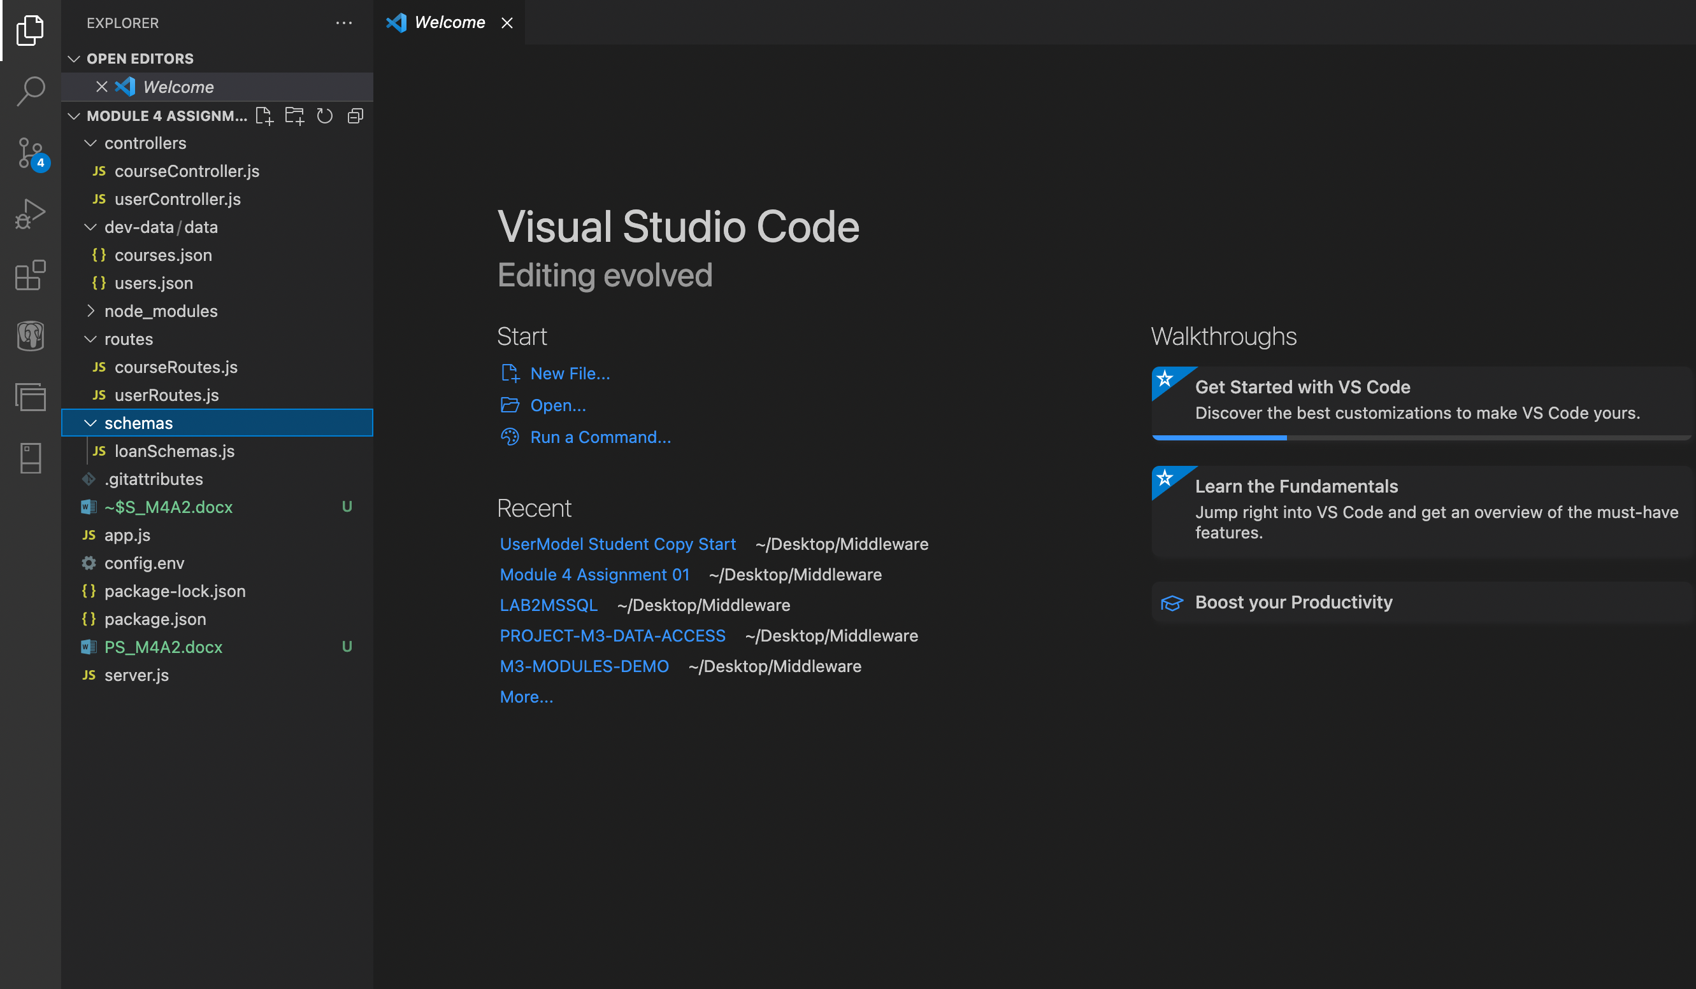

**Step 1: Start by Setting up additional environment variables in "config.env".**

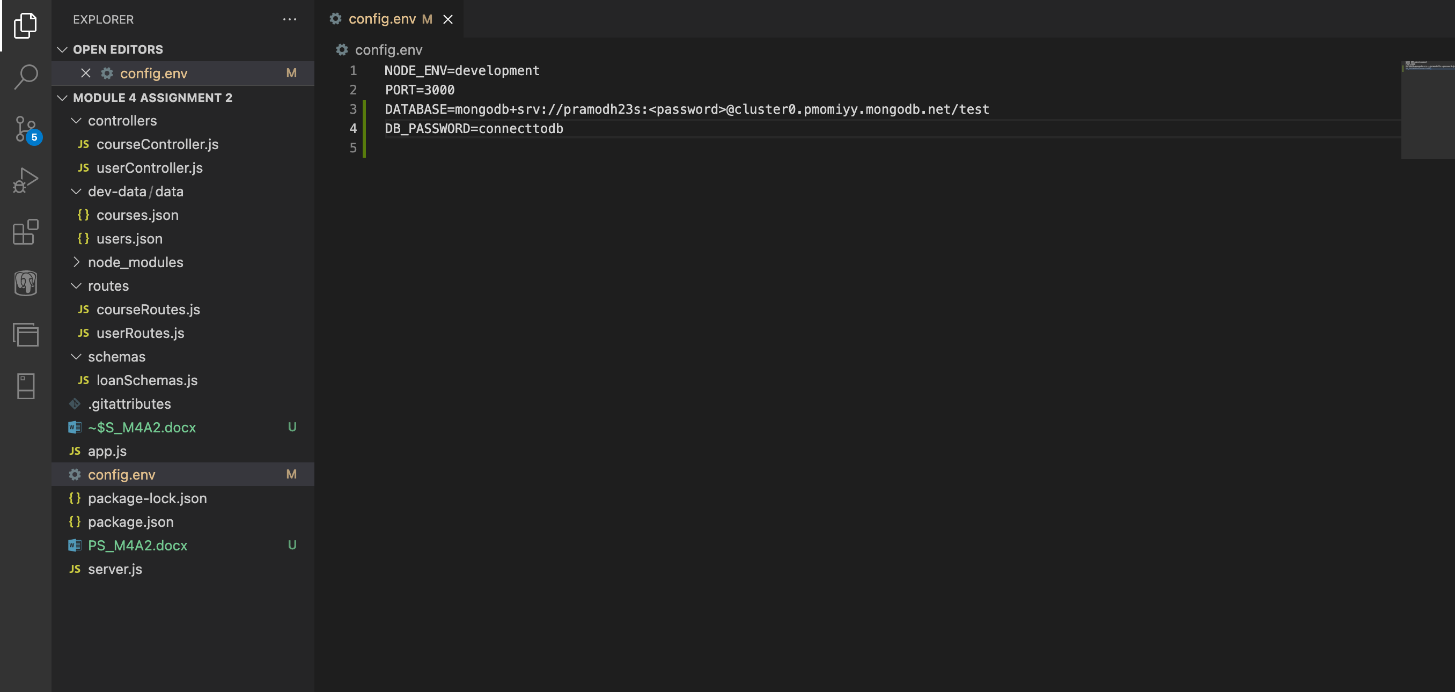

**Step 2: Create the associated files in the correct folder**

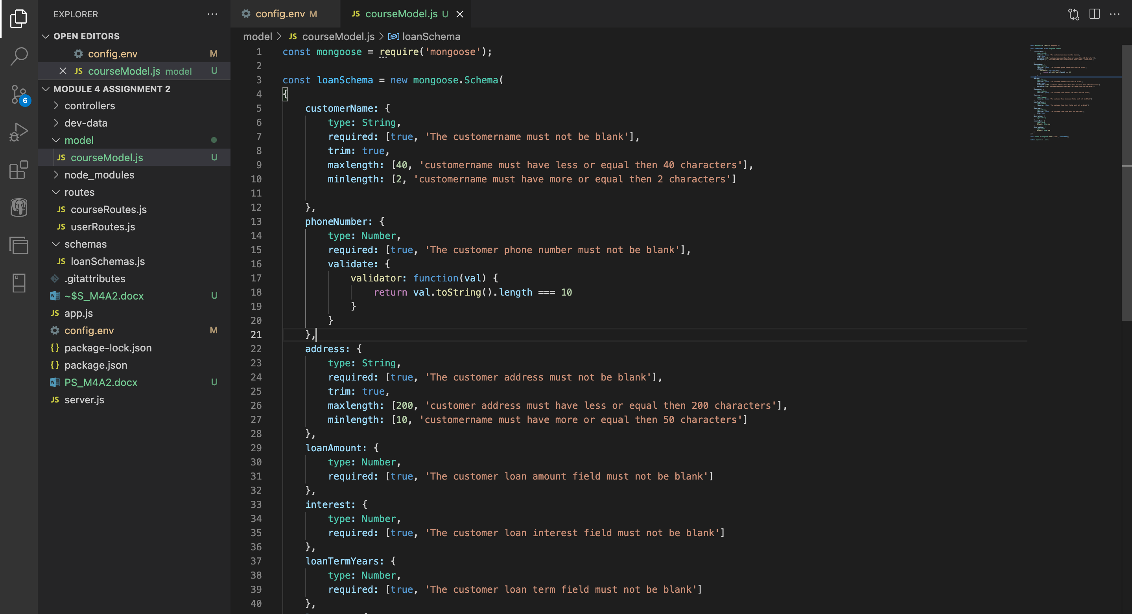

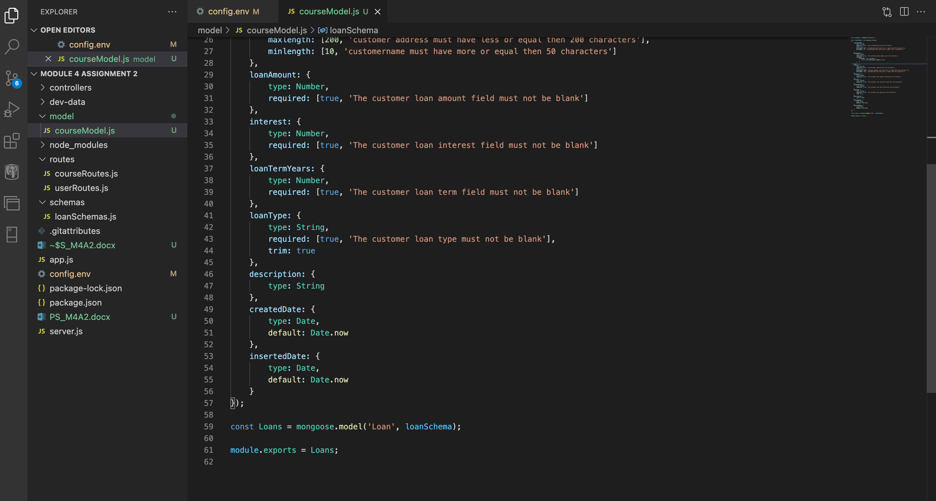

Code:

const mongoose = require('mongoose');

const loanSchema = new mongoose.Schema(

{

customerName: {

type: String,

required: [true, 'The customername must not be blank'],

trim: true,

maxlength: [40, 'customername must have less or equal then 40 characters'],

minlength: [2, 'customername must have more or equal then 2 characters']

},

phoneNumber: {

type: Number,

required: [true, 'The customer phone number must not be blank'],

validate: {

validator: function(val) {

return val.toString().length === 10

}

}

},

address: {

type: String,

required: [true, 'The customer address must not be blank'],

trim: true,

maxlength: [200, 'customer address must have less or equal then 200 characters'],

minlength: [10, 'customername must have more or equal then 50 characters']

},

loanAmount: {

type: Number,

required: [true, 'The customer loan amount field must not be blank']

},

interest: {

type: Number,

required: [true, 'The customer loan interest field must not be blank']

},

loanTermYears: {

type: Number,

required: [true, 'The customer loan term field must not be blank']

},

loanType: {

type: String,

required: [true, 'The customer loan type must not be blank'],

trim: true

},

description: {

type: String

},

createdDate: {

type: Date,

default: Date.now

},

insertedDate: {

type: Date,

default: Date.now

}

});

const Loans = mongoose.model('Loan', loanSchema);

module.exports = Loans;

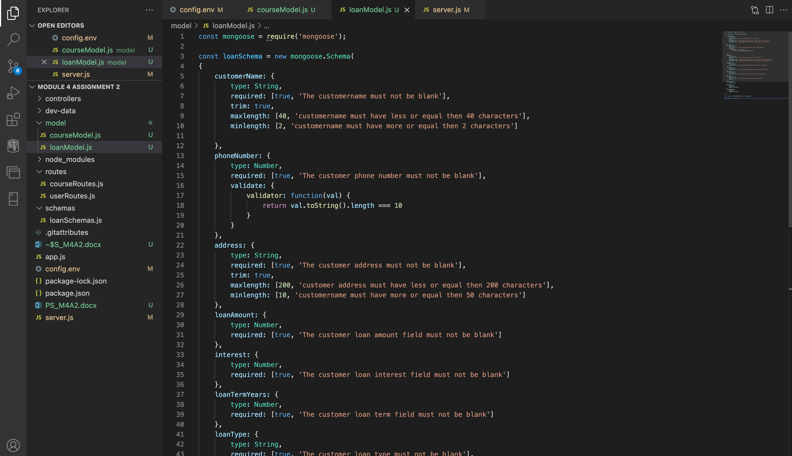

**Step 3: Creating the server.js file**

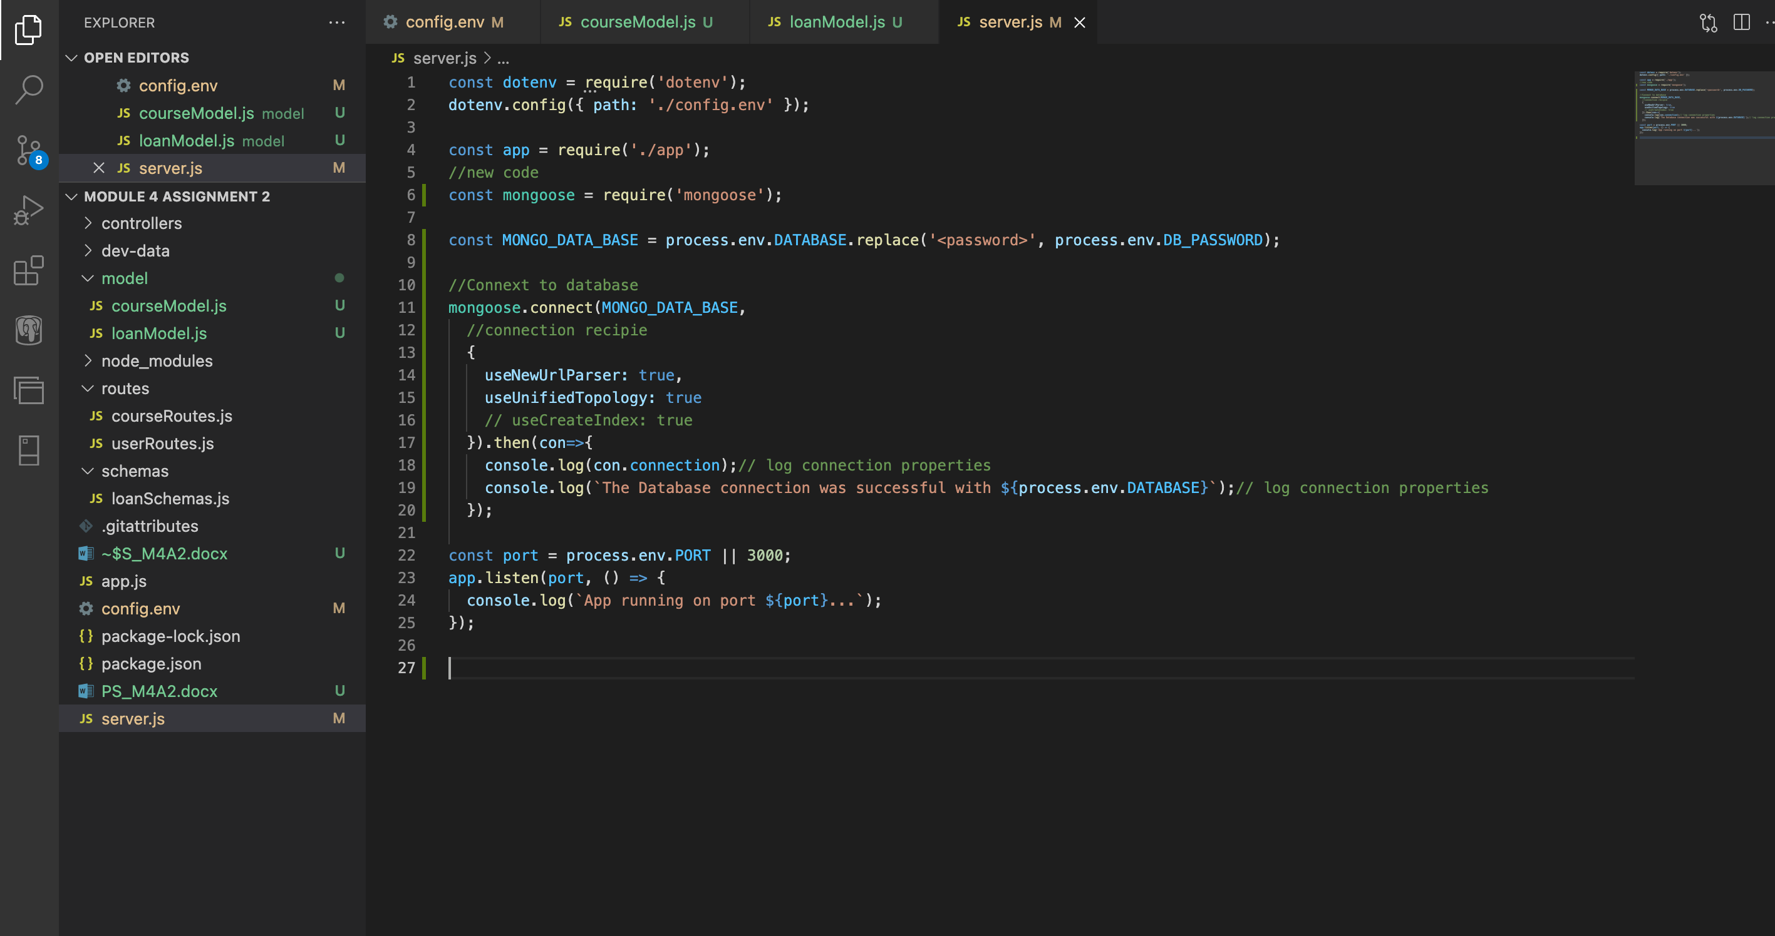

Code:

const dotenv = require('dotenv');

dotenv.config({ path: './config.env' });

const app = require('./app');

//new code

const mongoose = require('mongoose');

const MONGO_DATA_BASE = process.env.DATABASE.replace('<password>', process.env.DB_PASSWORD);

//Connext to database

mongoose.connect(MONGO_DATA_BASE,

//connection recipie

{

useNewUrlParser: true,

useUnifiedTopology: true

// useCreateIndex: true

}).then(con=>{

console.log(con.connection);// log connection properties

console.log(`The Database connection was successful with ${process.env.DATABASE}`);// log connection properties

});

const port = process.env.PORT || 3000;

app.listen(port, () => {

console.log(`App running on port ${port}...`);

});

**Step 4: Creating the dataBaseManager folder in the project and adding the loanDbContext.js file in the folder.**

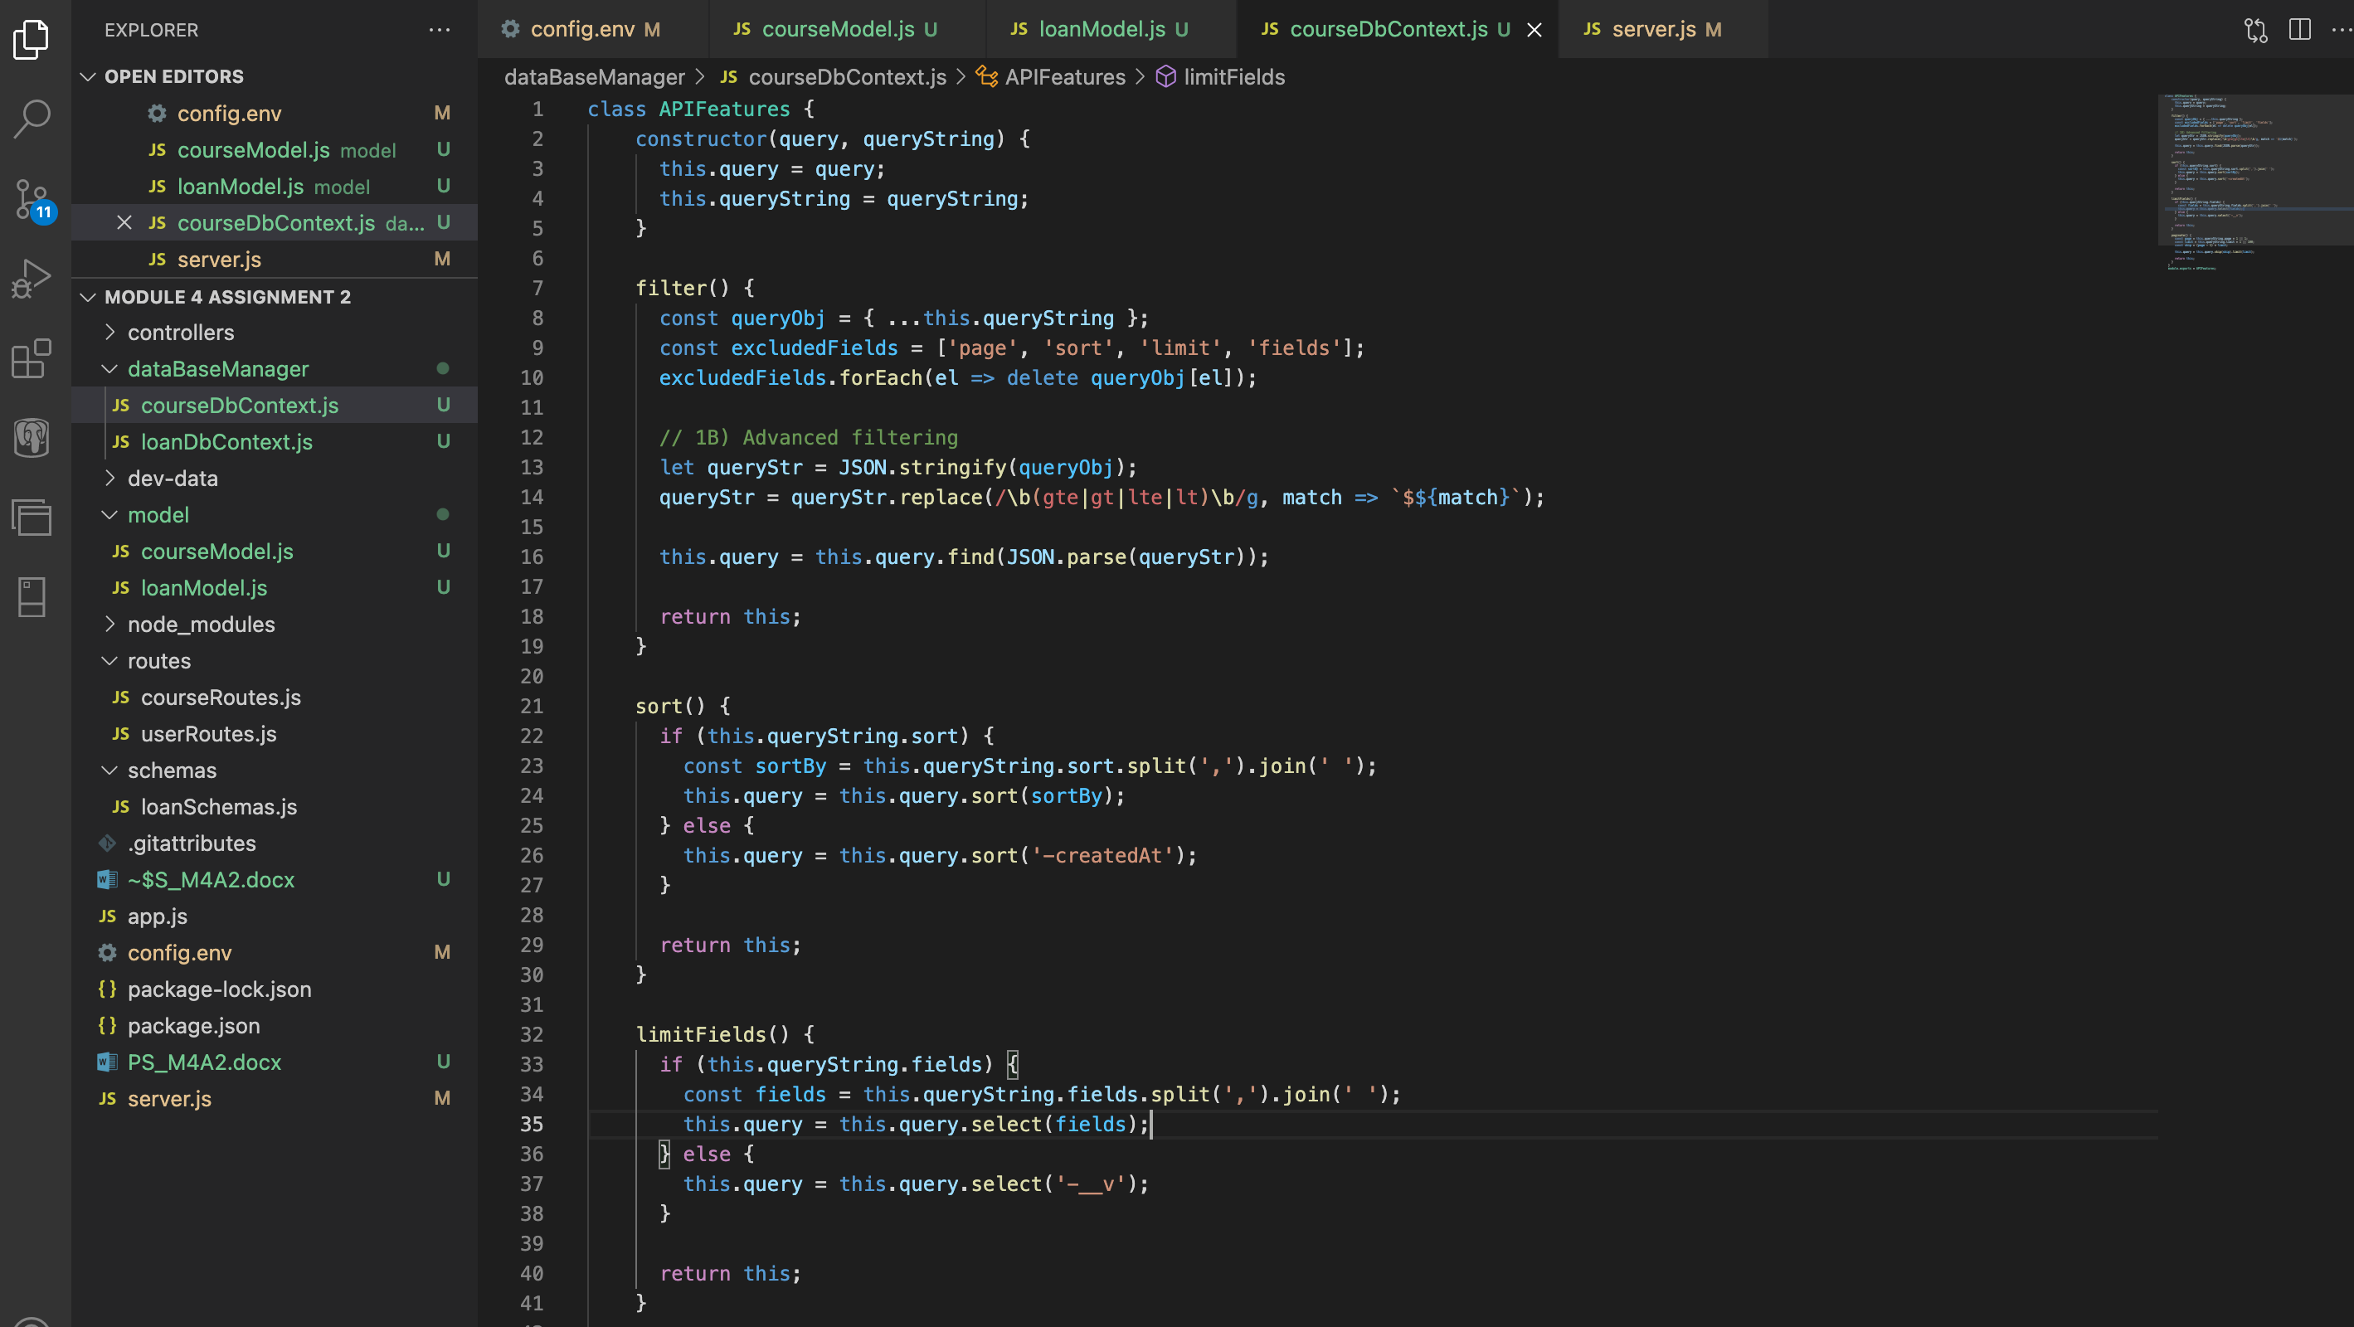

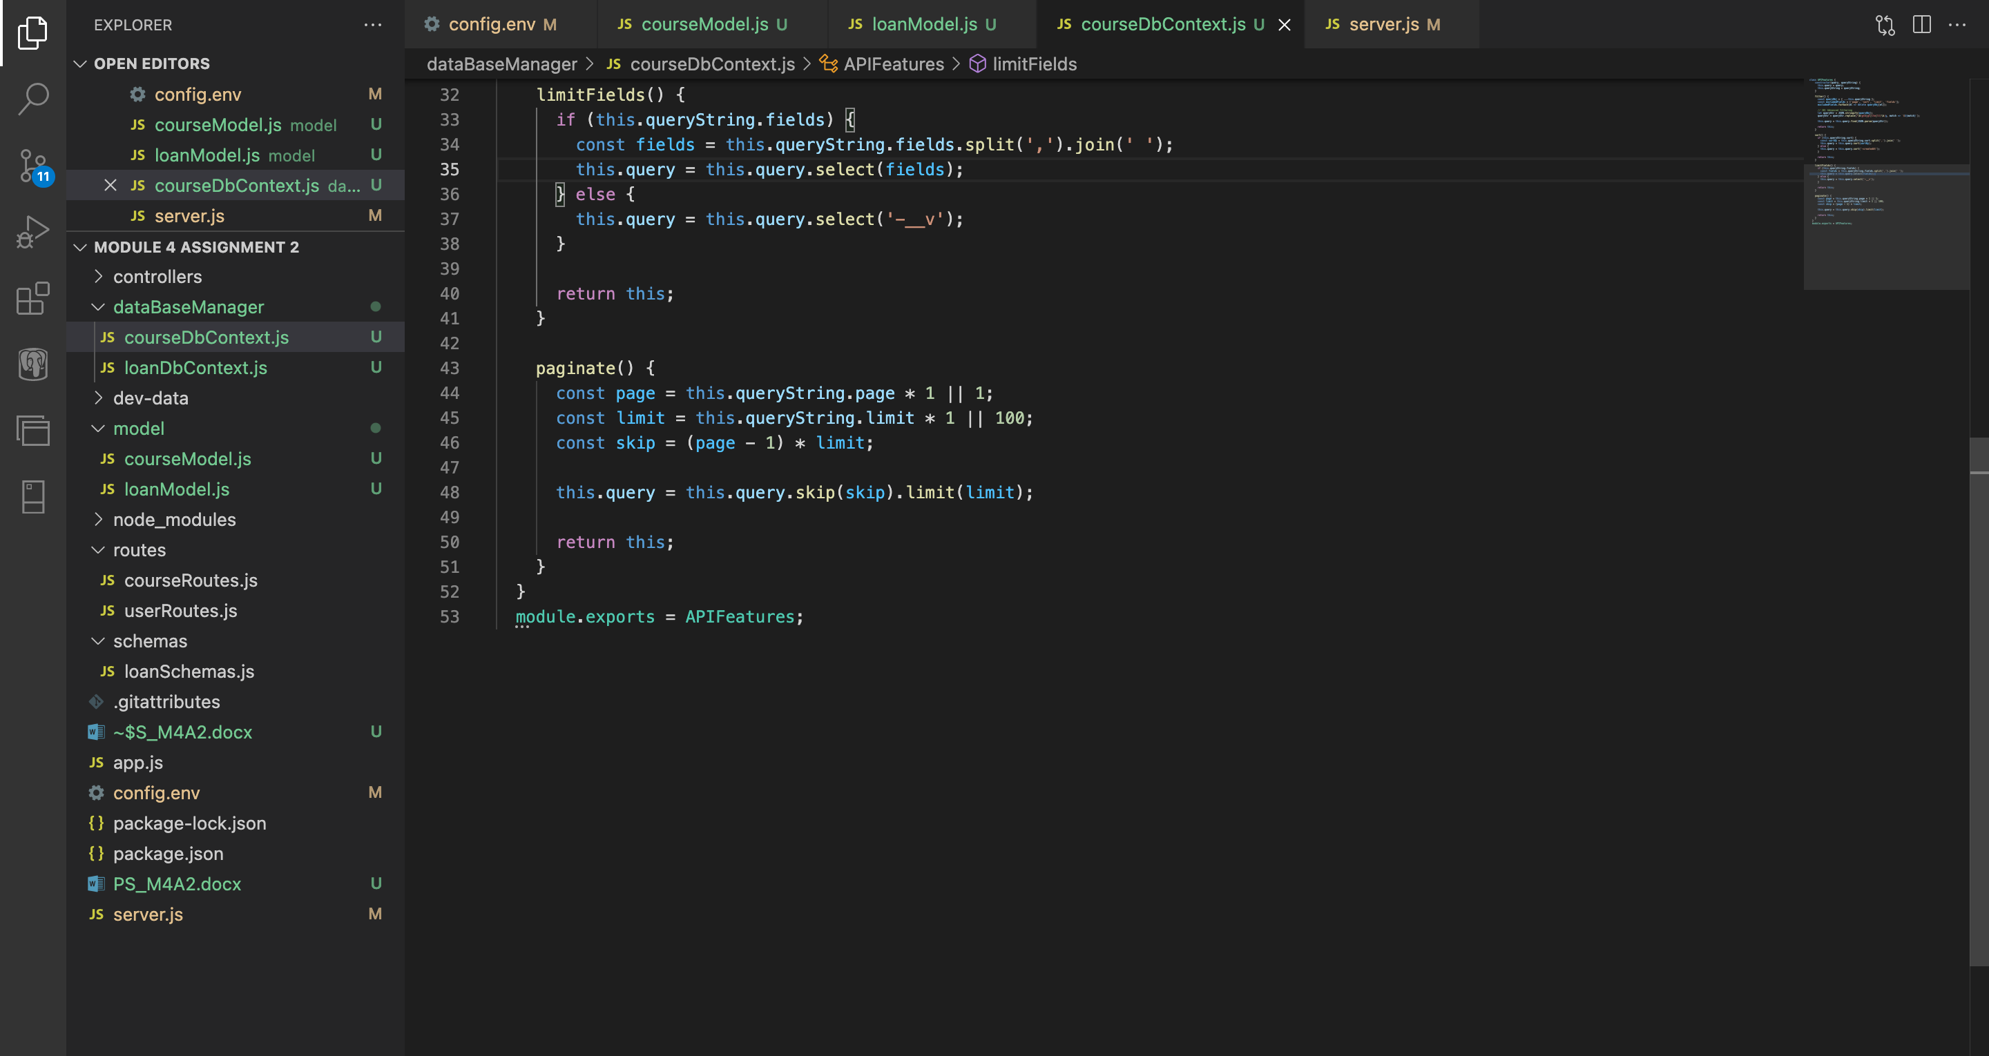

Code:

class APIFeatures {

constructor(query, queryString) {

this.query = query;

this.queryString = queryString;

}

filter() {

const queryObj = { ...this.queryString };

const excludedFields = ['page', 'sort', 'limit', 'fields'];

excludedFields.forEach(el => delete queryObj[el]);

// 1B) Advanced filtering

let queryStr = JSON.stringify(queryObj);

queryStr = queryStr.replace(/\b(gte|gt|lte|lt)\b/g, match => `$${match}`);

this.query = this.query.find(JSON.parse(queryStr));

return this;

}

sort() {

if (this.queryString.sort) {

const sortBy = this.queryString.sort.split(',').join(' ');

this.query = this.query.sort(sortBy);

} else {

this.query = this.query.sort('-createdAt');

}

return this;

}

limitFields() {

if (this.queryString.fields) {

const fields = this.queryString.fields.split(',').join(' ');

this.query = this.query.select(fields);

} else {

this.query = this.query.select('-__v');

}

return this;

}

paginate() {

const page = this.queryString.page * 1 || 1;

const limit = this.queryString.limit * 1 || 100;

const skip = (page - 1) * limit;

this.query = this.query.skip(skip).limit(limit);

return this;

}

}

module.exports = APIFeatures;

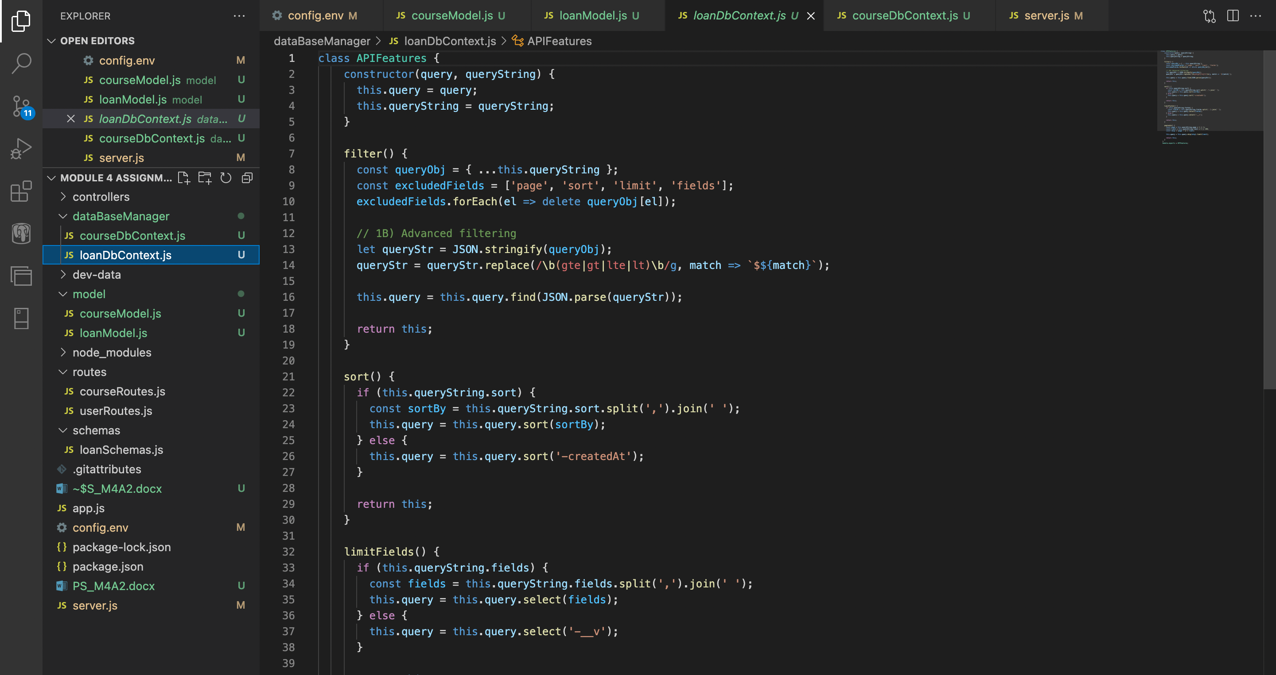

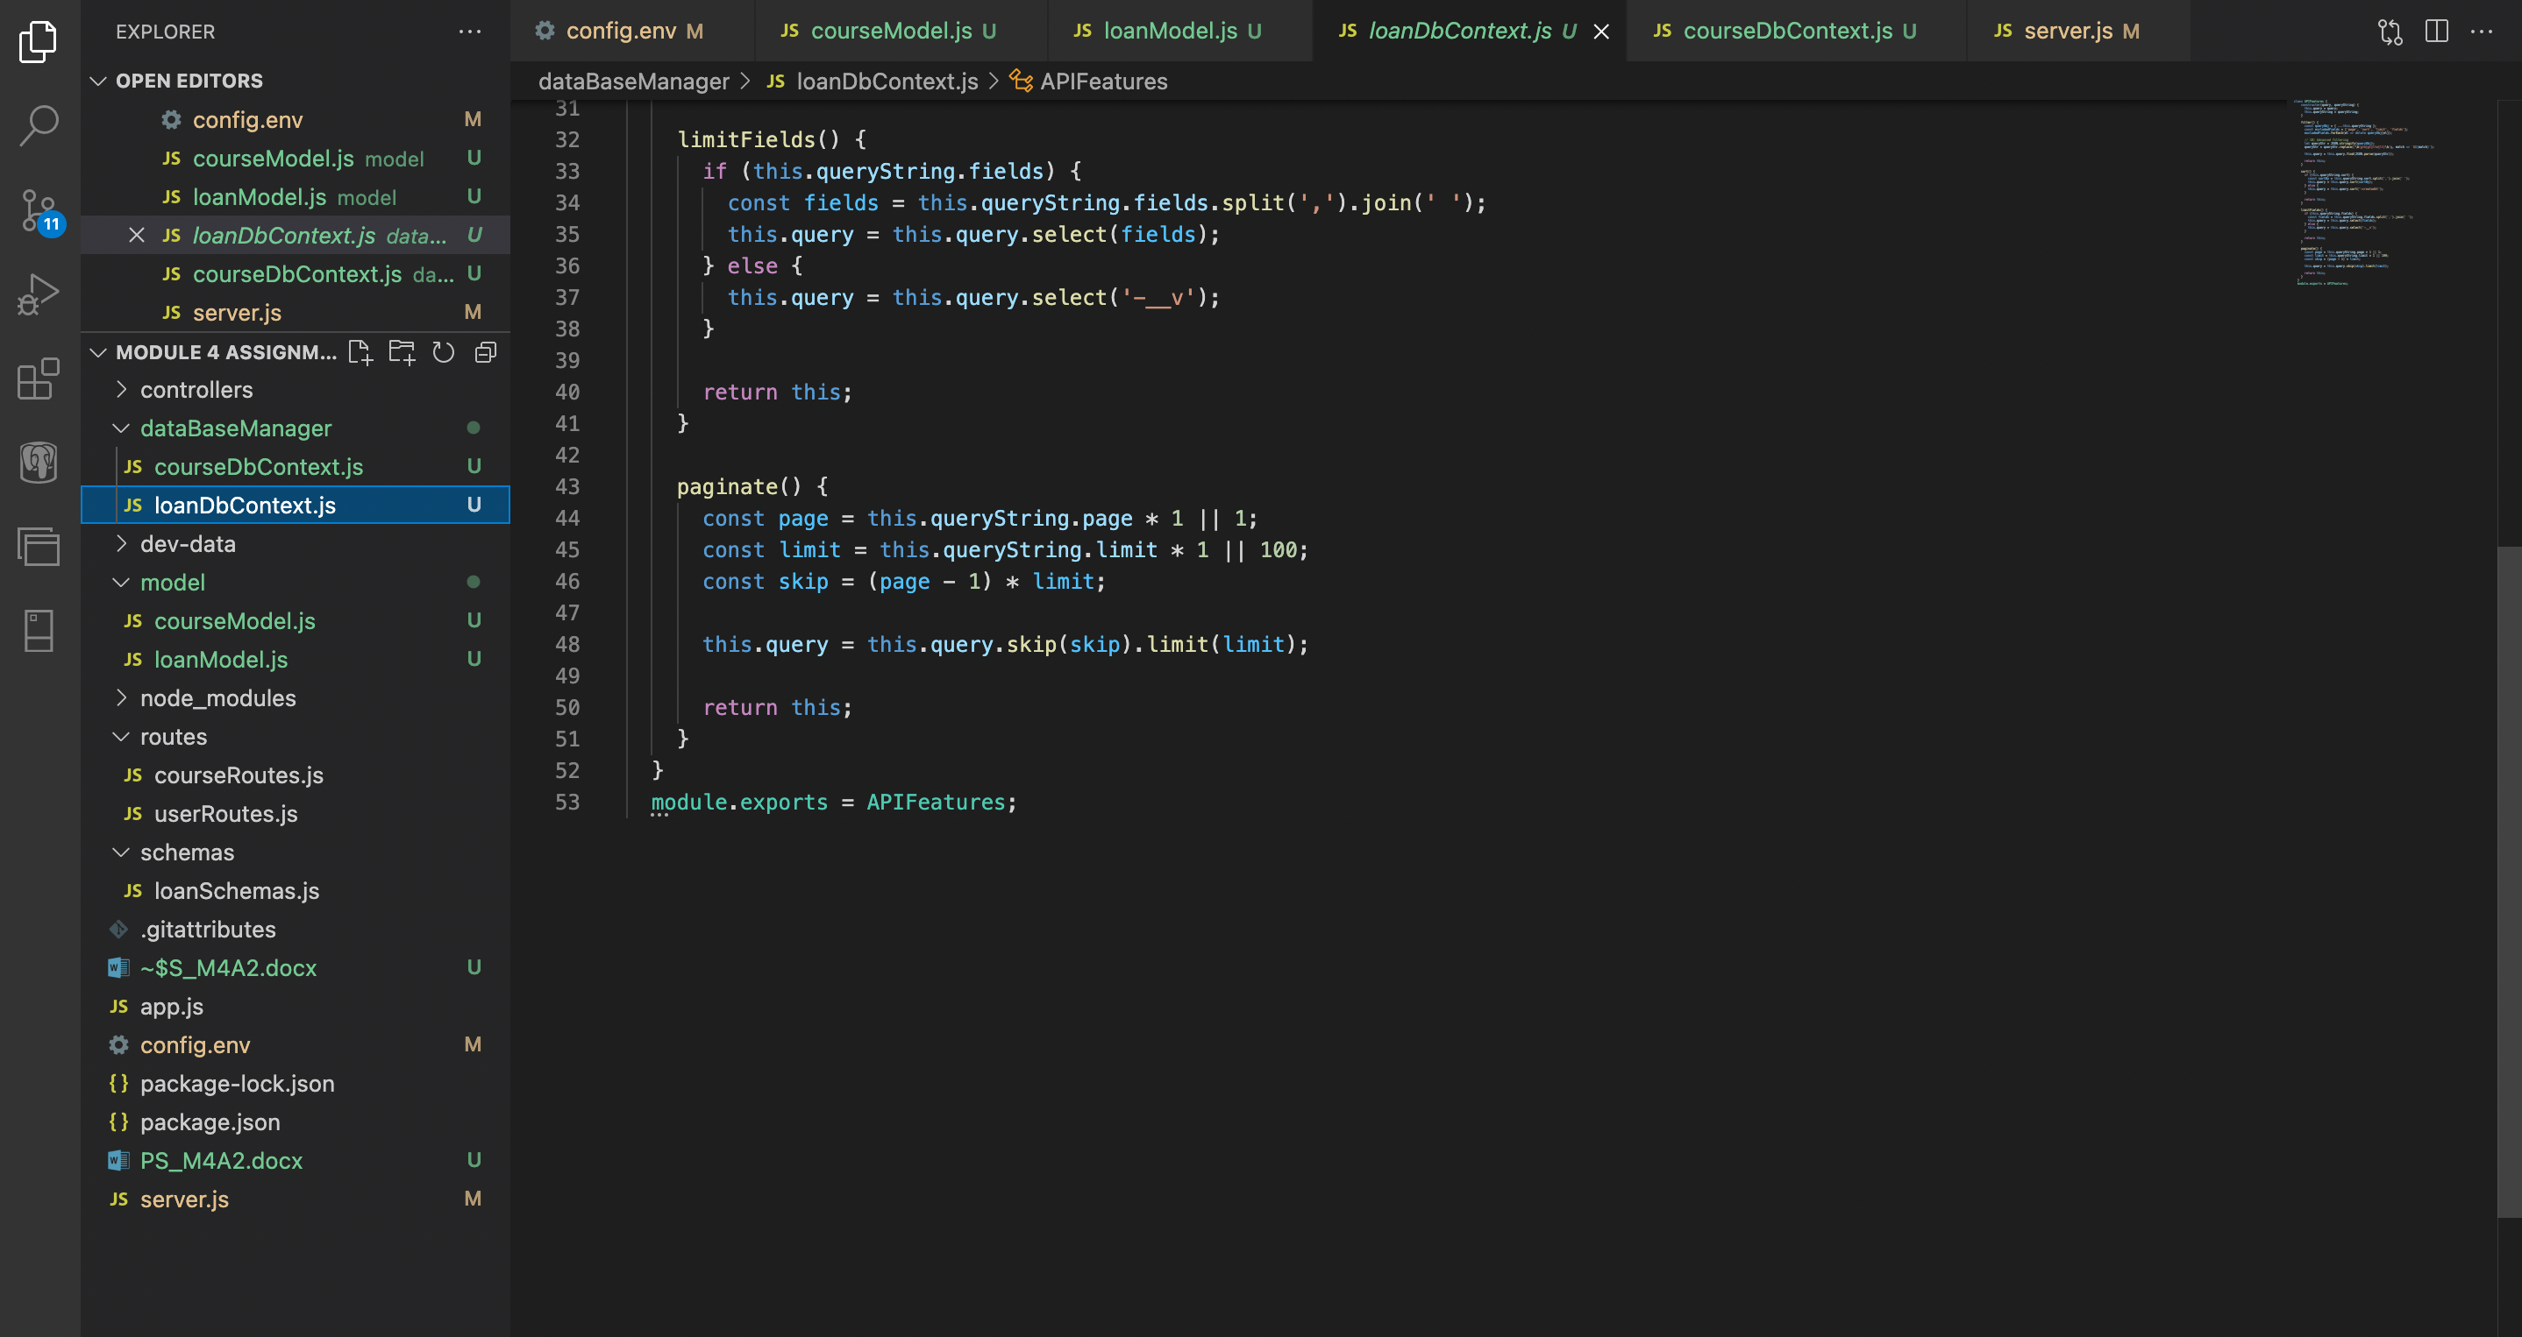

Code:

class APIFeatures {

constructor(query, queryString) {

this.query = query;

this.queryString = queryString;

}

filter() {

const queryObj = { ...this.queryString };

const excludedFields = ['page', 'sort', 'limit', 'fields'];

excludedFields.forEach(el => delete queryObj[el]);

// 1B) Advanced filtering

let queryStr = JSON.stringify(queryObj);

queryStr = queryStr.replace(/\b(gte|gt|lte|lt)\b/g, match => `$${match}`);

this.query = this.query.find(JSON.parse(queryStr));

return this;

}

sort() {

if (this.queryString.sort) {

const sortBy = this.queryString.sort.split(',').join(' ');

this.query = this.query.sort(sortBy);

} else {

this.query = this.query.sort('-createdAt');

}

return this;

}

limitFields() {

if (this.queryString.fields) {

const fields = this.queryString.fields.split(',').join(' ');

this.query = this.query.select(fields);

} else {

this.query = this.query.select('-__v');

}

return this;

}

paginate() {

const page = this.queryString.page * 1 || 1;

const limit = this.queryString.limit * 1 || 100;

const skip = (page - 1) * limit;

this.query = this.query.skip(skip).limit(limit);

return this;

}

}

module.exports = APIFeatures;

**Step 5: Creating the loanController.js file in the controllers folder of the project.**

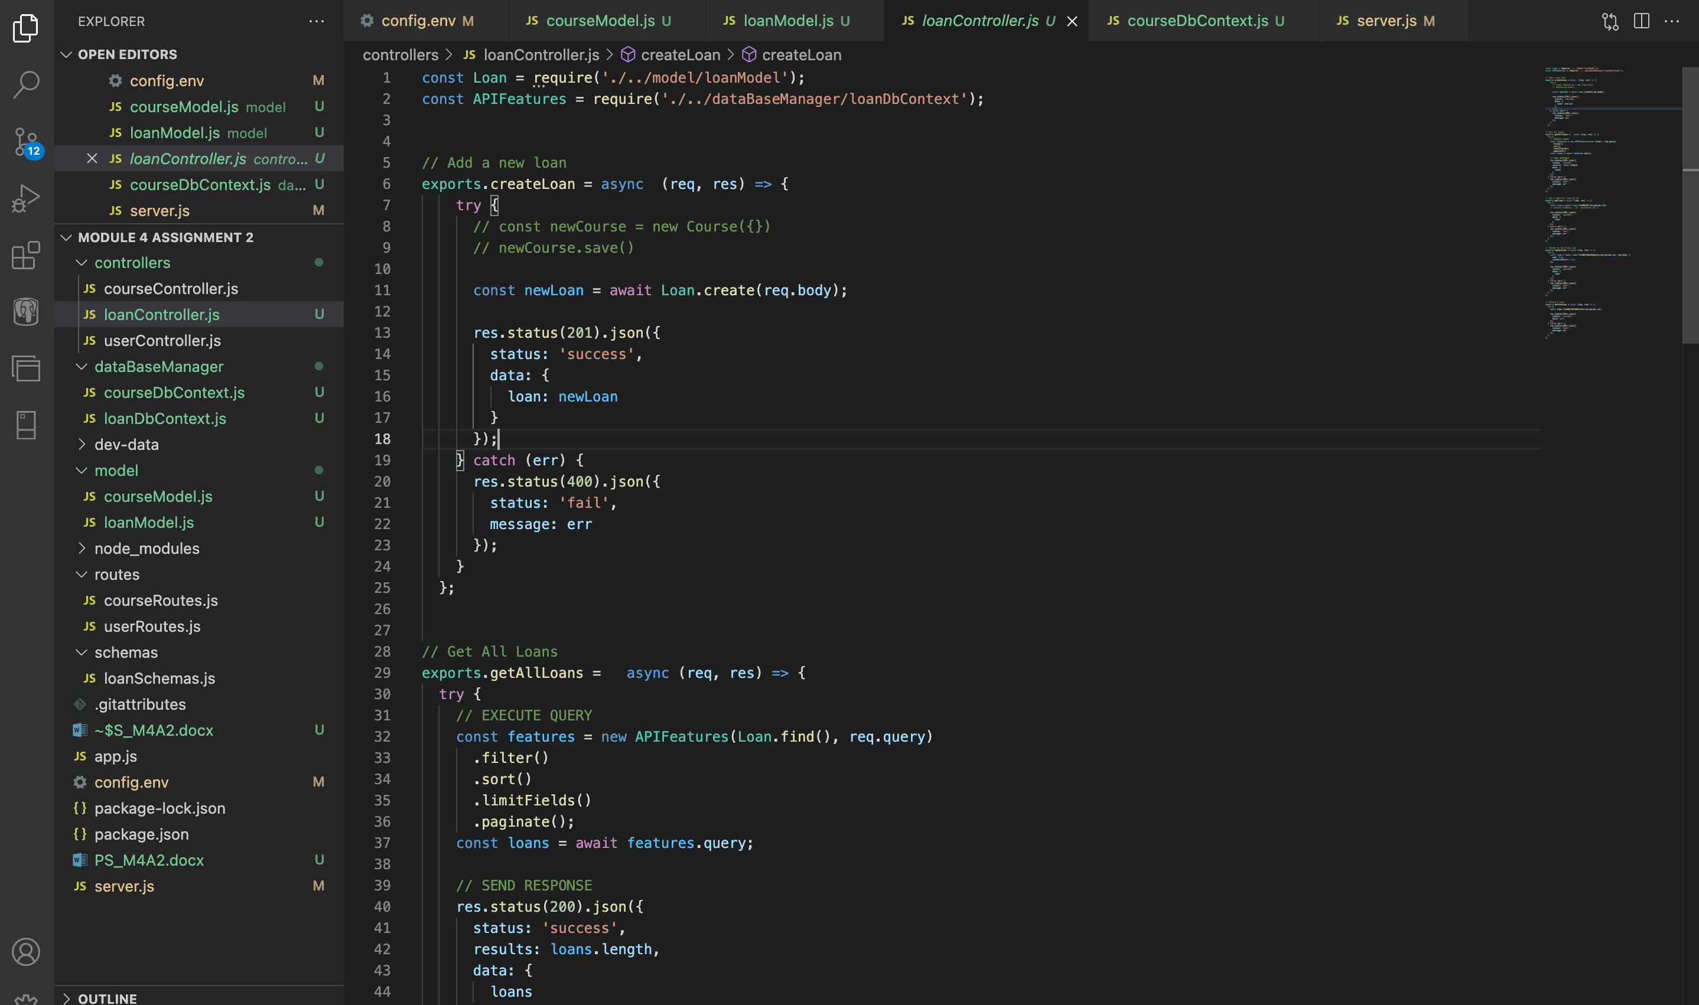

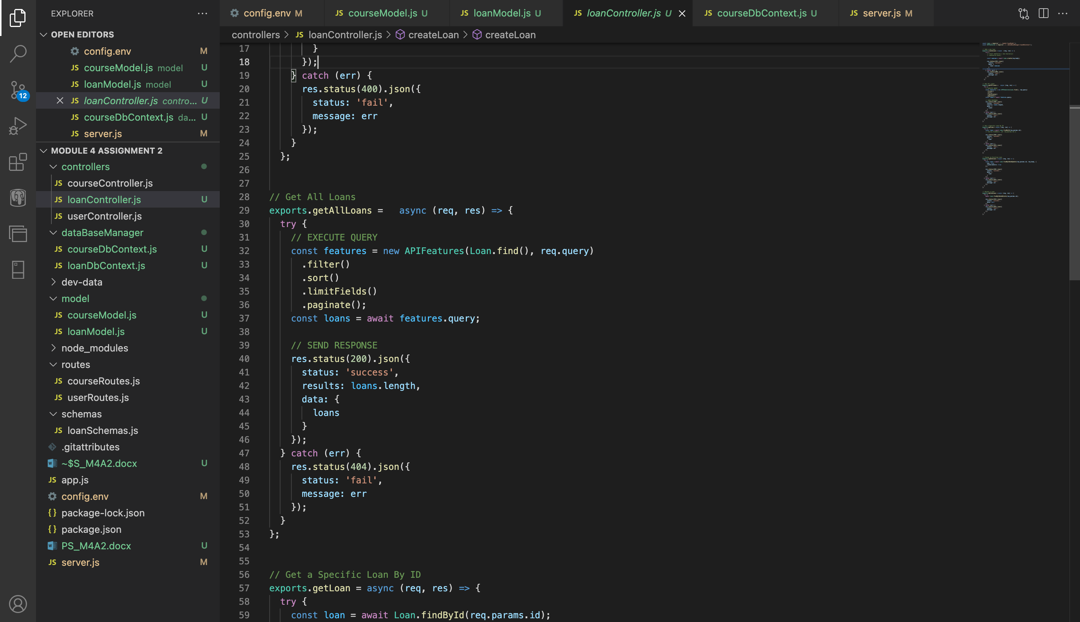

Code:

const Loan = require('./../model/loanModel');

const APIFeatures = require('./../dataBaseManager/loanDbContext');

// Add a new loan

exports.createLoan = async (req, res) => {

try {

// const newCourse = new Course({})

// newCourse.save()

const newLoan = await Loan.create(req.body);

res.status(201).json({

status: 'success',

data: {

loan: newLoan

}

});

} catch (err) {

res.status(400).json({

status: 'fail',

message: err

});

}

};

// Get All Loans

exports.getAllLoans = async (req, res) => {

try {

// EXECUTE QUERY

const features = new APIFeatures(Loan.find(), req.query)

.filter()

.sort()

.limitFields()

.paginate();

const loans = await features.query;

// SEND RESPONSE

res.status(200).json({

status: 'success',

results: loans.length,

data: {

loans

}

});

} catch (err) {

res.status(404).json({

status: 'fail',

message: err

});

}

};

// Get a Specific Loan By ID

exports.getLoan = async (req, res) => {

try {

const loan = await Loan.findById(req.params.id);

// Course.findOne({ _id: req.params.id })

res.status(200).json({

status: 'success',

data: {

loan

}

});

} catch (err) {

res.status(404).json({

status: 'fail',

message: err

});

}

};

// Change an Existing Loan

exports.updateLoan = async (req, res) => {

try {

const loan = await Loan.findByIdAndUpdate(req.params.id, req.body, {

new: true,

runValidators: true

});

res.status(200).json({

status: 'success',

data: {

loan

}

});

} catch (err) {

res.status(404).json({

status: 'fail',

message: err

});

}

};

// Delete a Loan

exports.deleteLoan = async (req, res) => {

try {

await Loan.findByIdAndDelete(req.params.id);

res.status(204).json({

status: 'success',

data: null

});

} catch (err) {

res.status(404).json({

status: 'fail',

message: err

});

}

};

**Step 6: Creating the loanRoutes.js file in the routes folder, and loading the routes in the "app.js" file of the project**

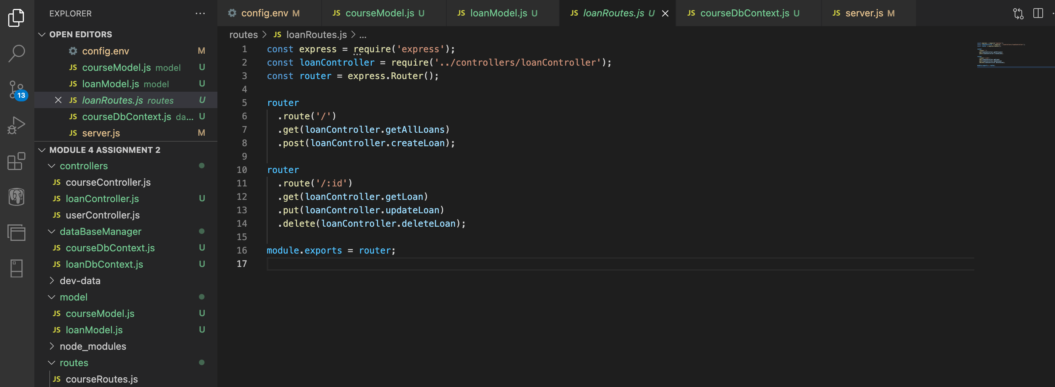

Code:

const express = require('express');

const loanController = require('../controllers/loanController');

const router = express.Router();

router

.route('/')

.get(loanController.getAllLoans)

.post(loanController.createLoan);

router

.route('/:id')

.get(loanController.getLoan)

.put(loanController.updateLoan)

.delete(loanController.deleteLoan);

module.exports = router;

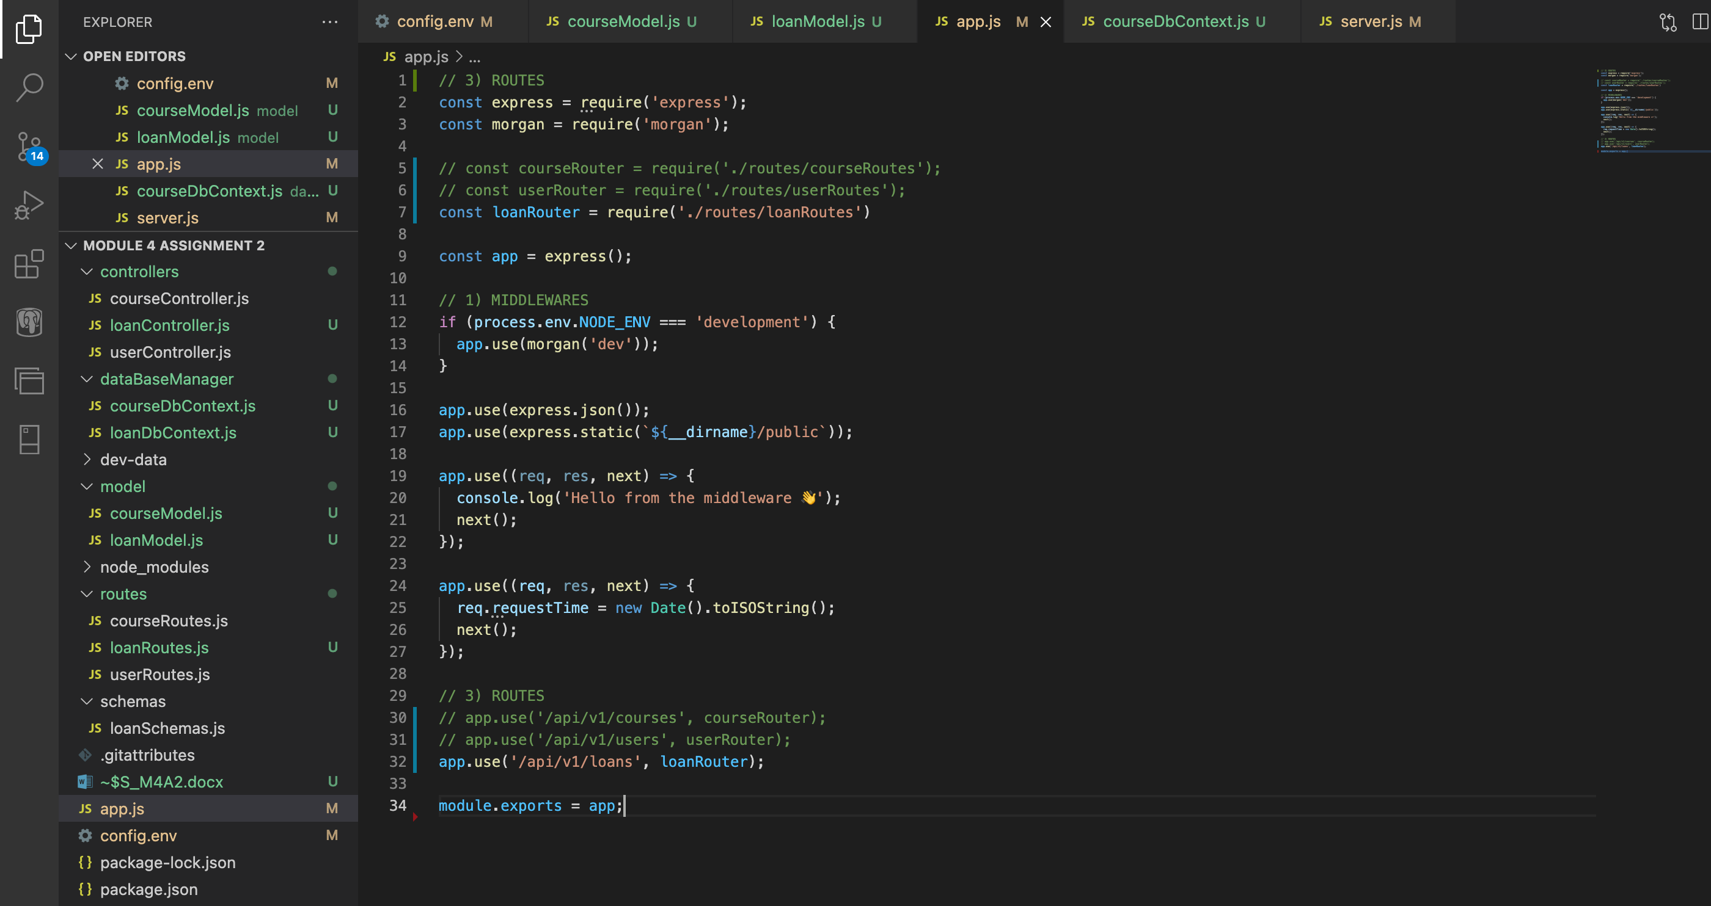

Code:

// 3) ROUTES

const express = require('express');

const morgan = require('morgan');

// const courseRouter = require('./routes/courseRoutes');

// const userRouter = require('./routes/userRoutes');

const loanRouter = require('./routes/loanRoutes')

const app = express();

// 1) MIDDLEWARES

if (process.env.NODE_ENV === 'development') {

app.use(morgan('dev'));

}

app.use(express.json());

app.use(express.static(`${__dirname}/public`));

app.use((req, res, next) => {

console.log('Hello from the middleware 👋');

next();

});

app.use((req, res, next) => {

req.requestTime = new Date().toISOString();

next();

});

// 3) ROUTES

// app.use('/api/v1/courses', courseRouter);

// app.use('/api/v1/users', userRouter);

app.use('/api/v1/loans', loanRouter);

module.exports = app;

**Requirements:**

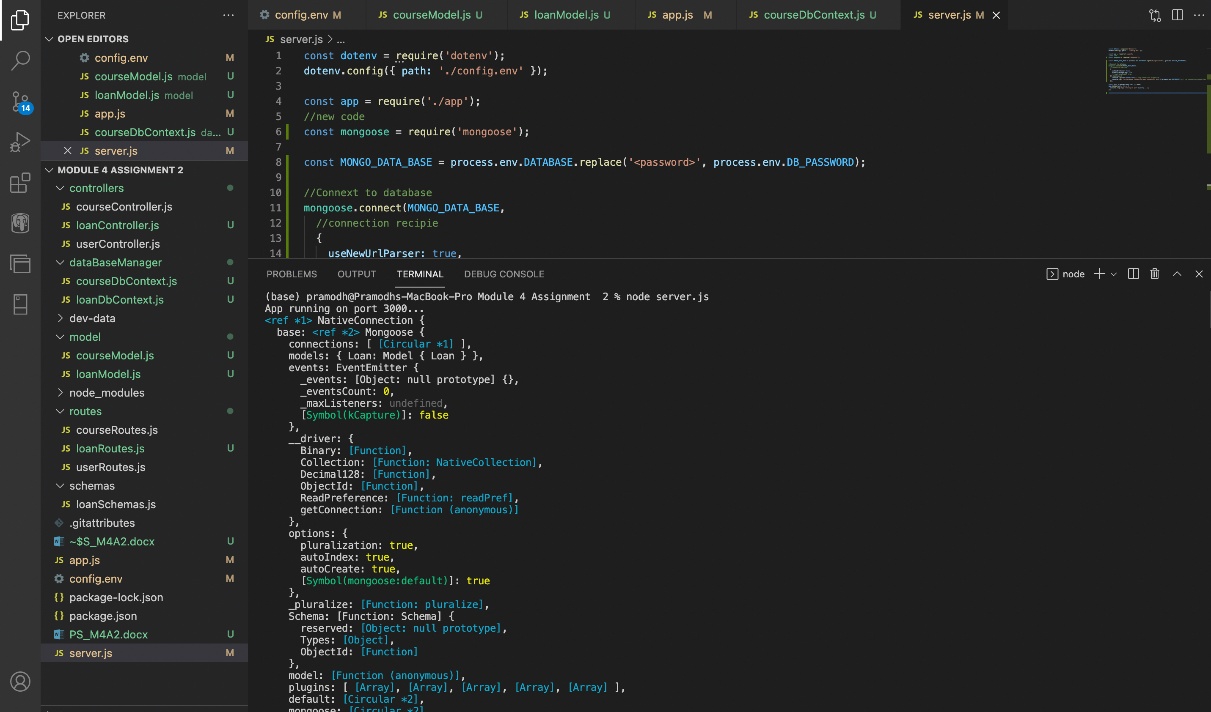

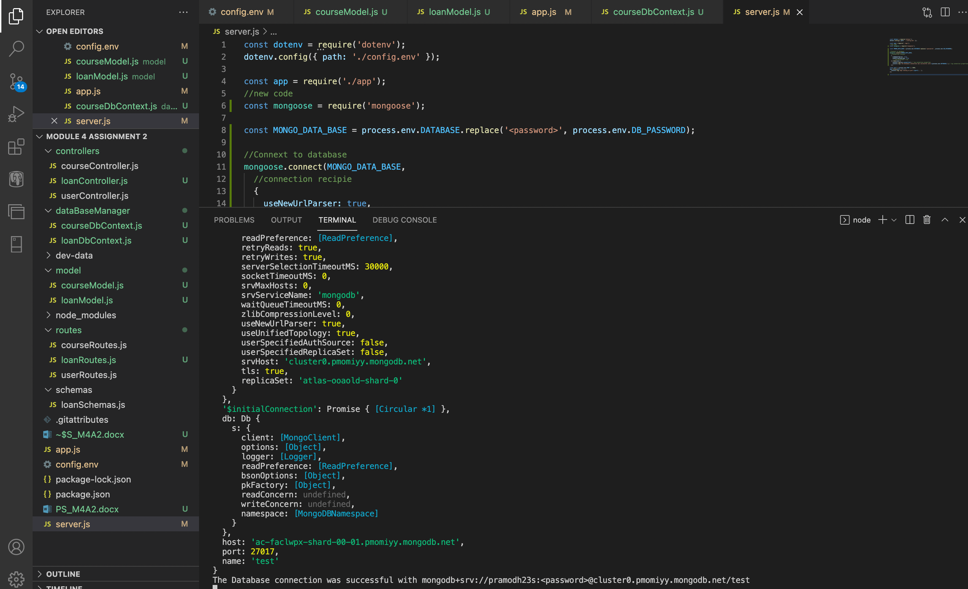

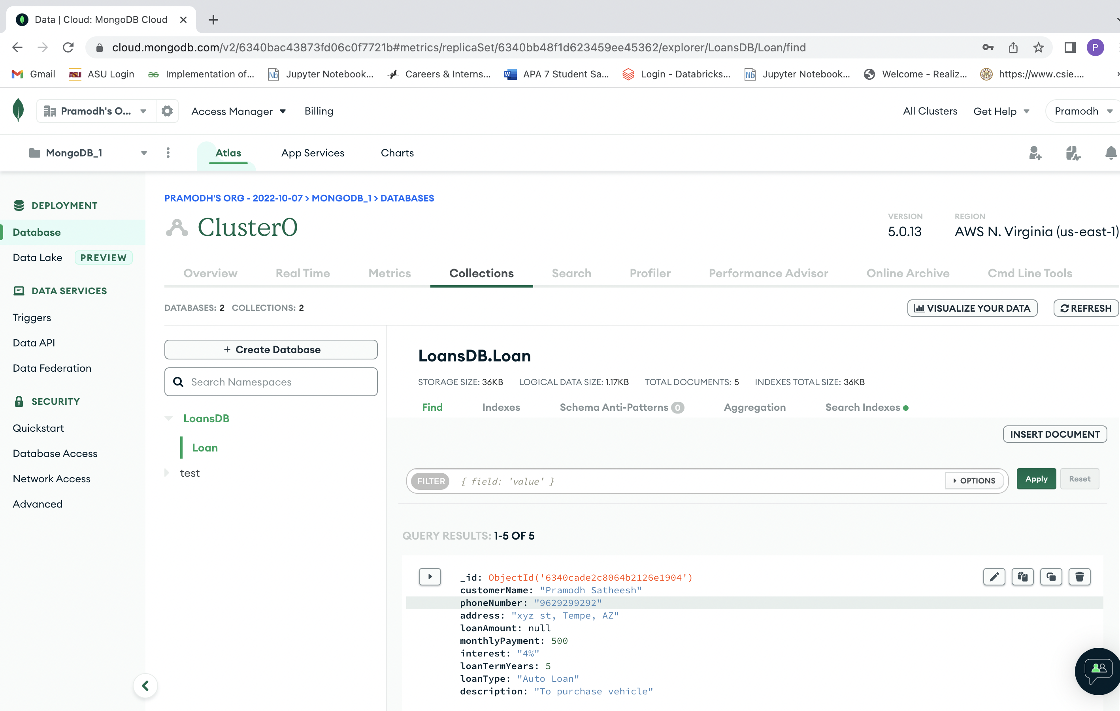

**Testing with Postman**

1. **Adding a new loan**

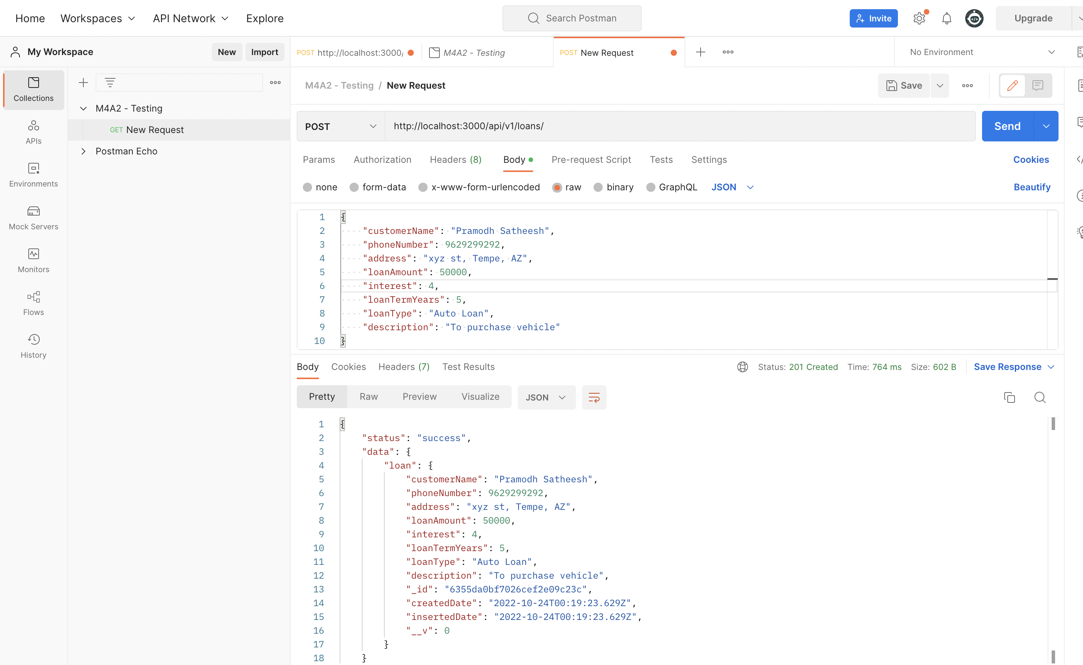

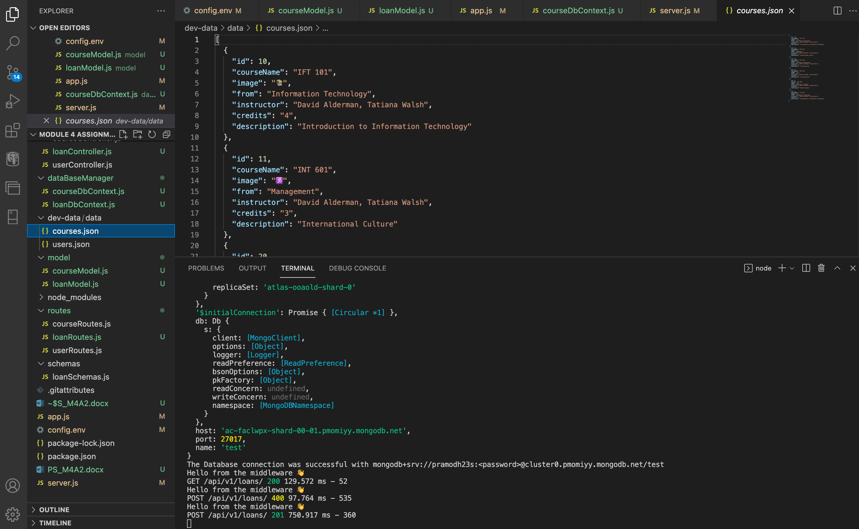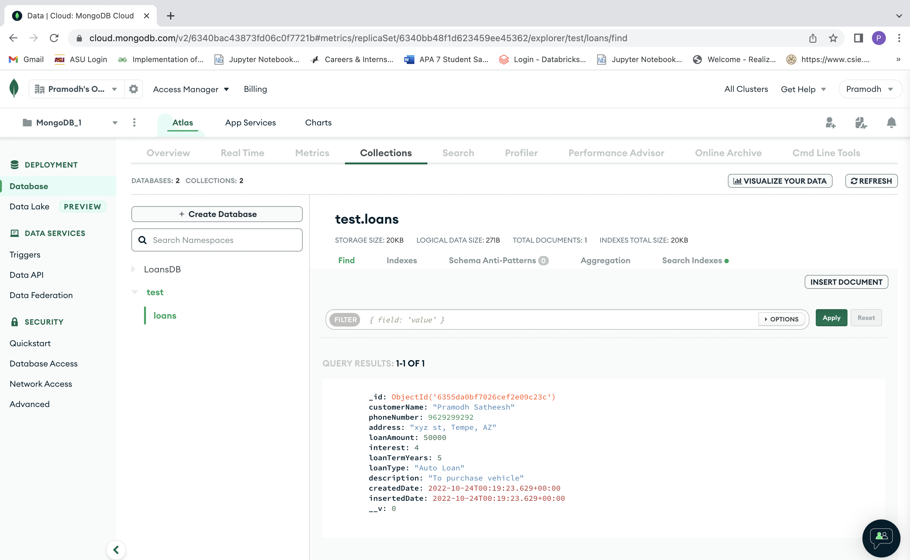

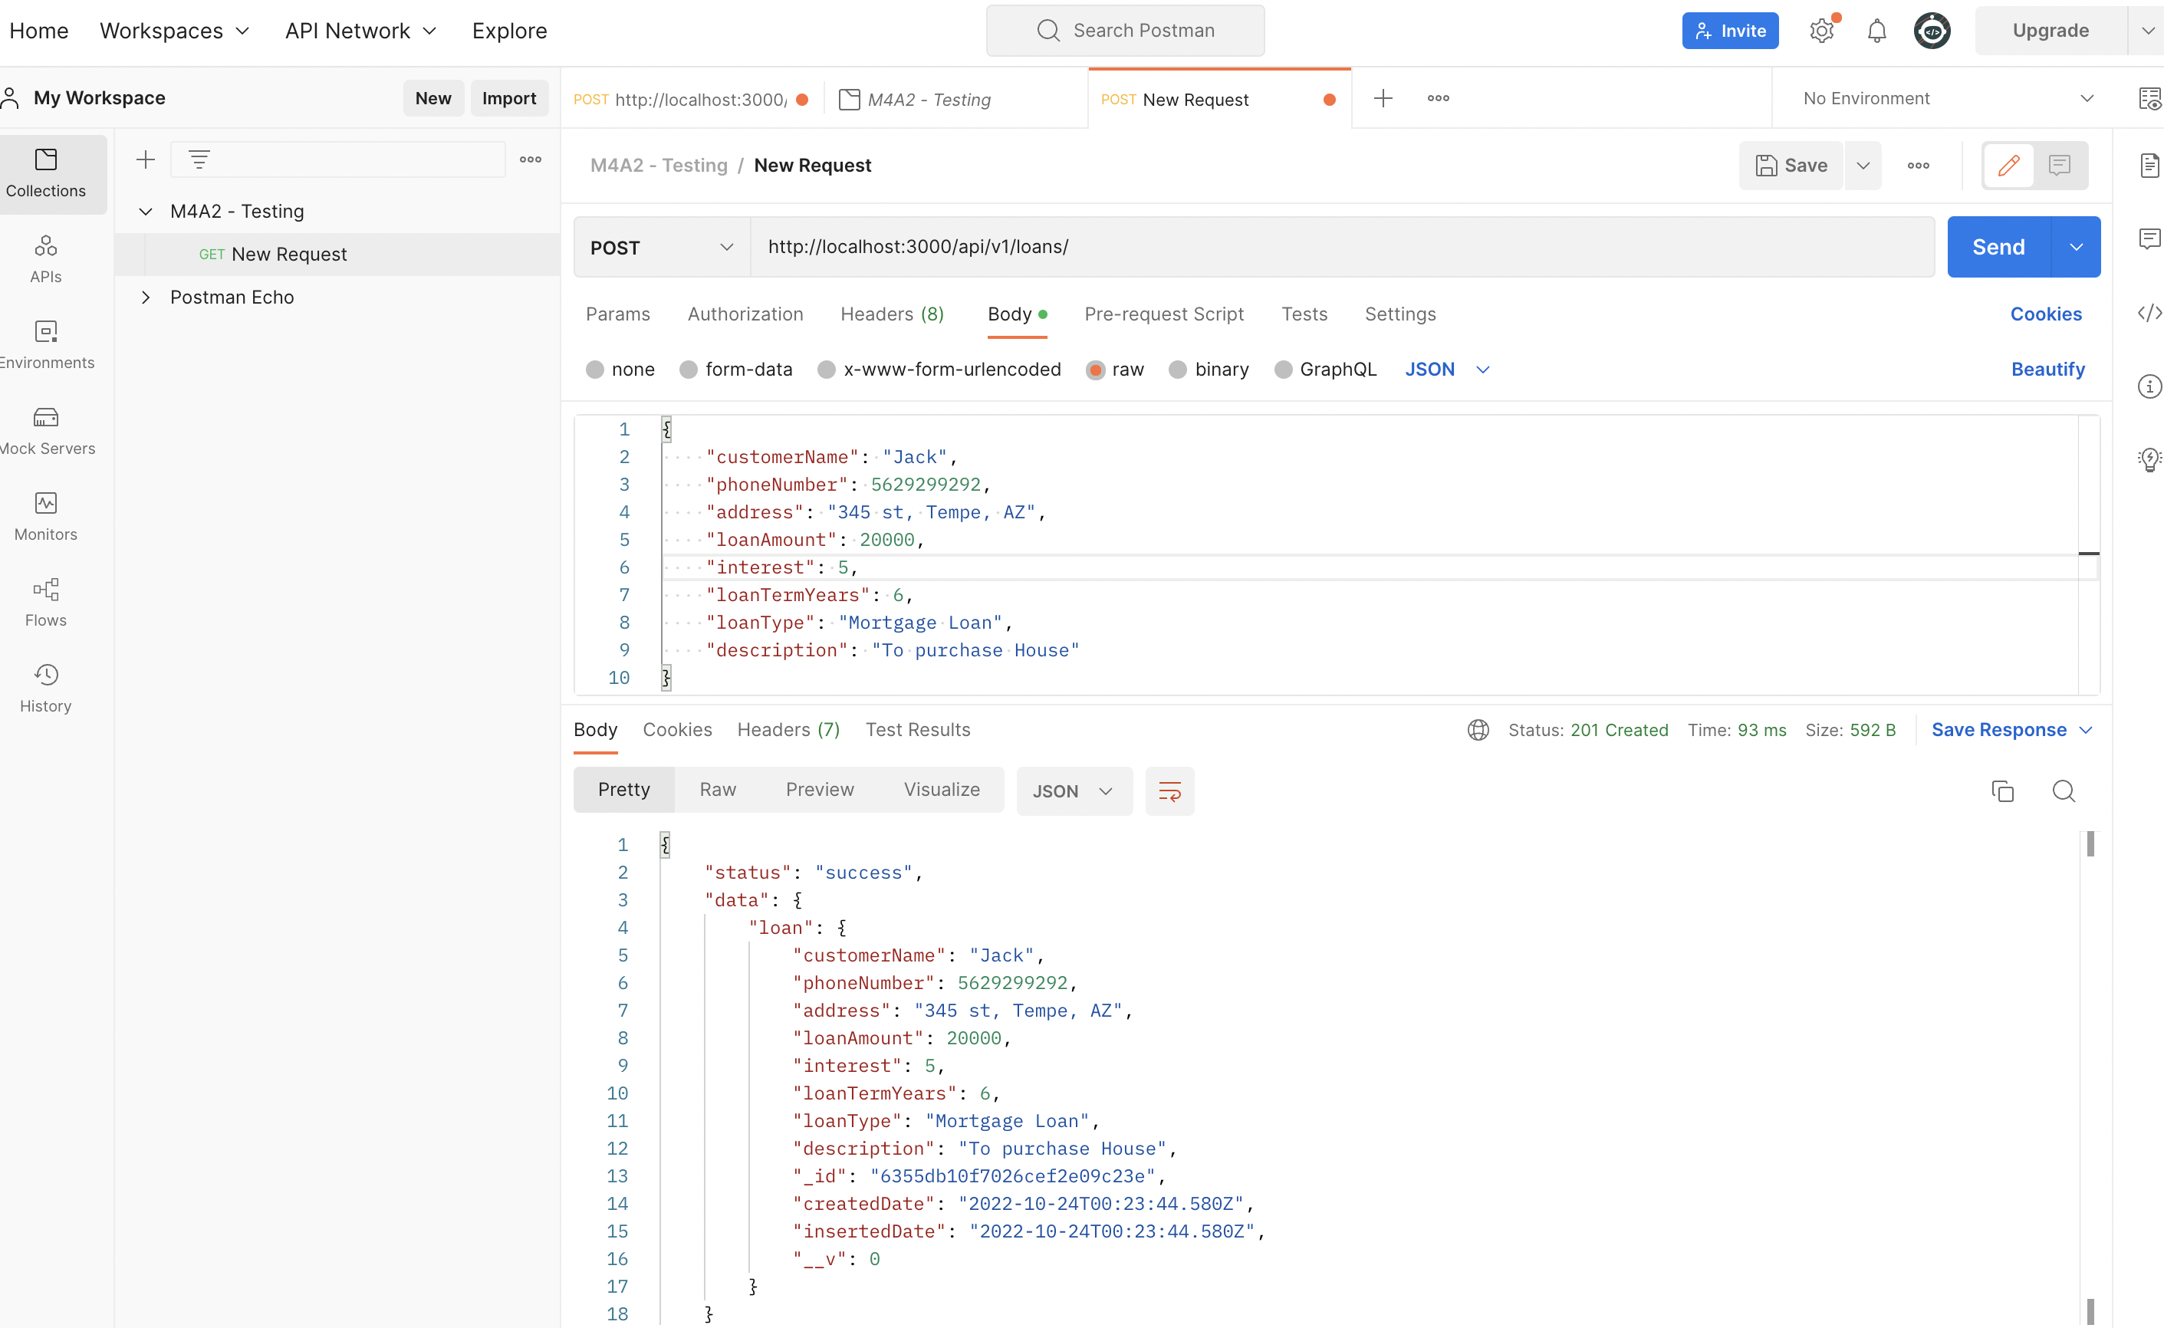

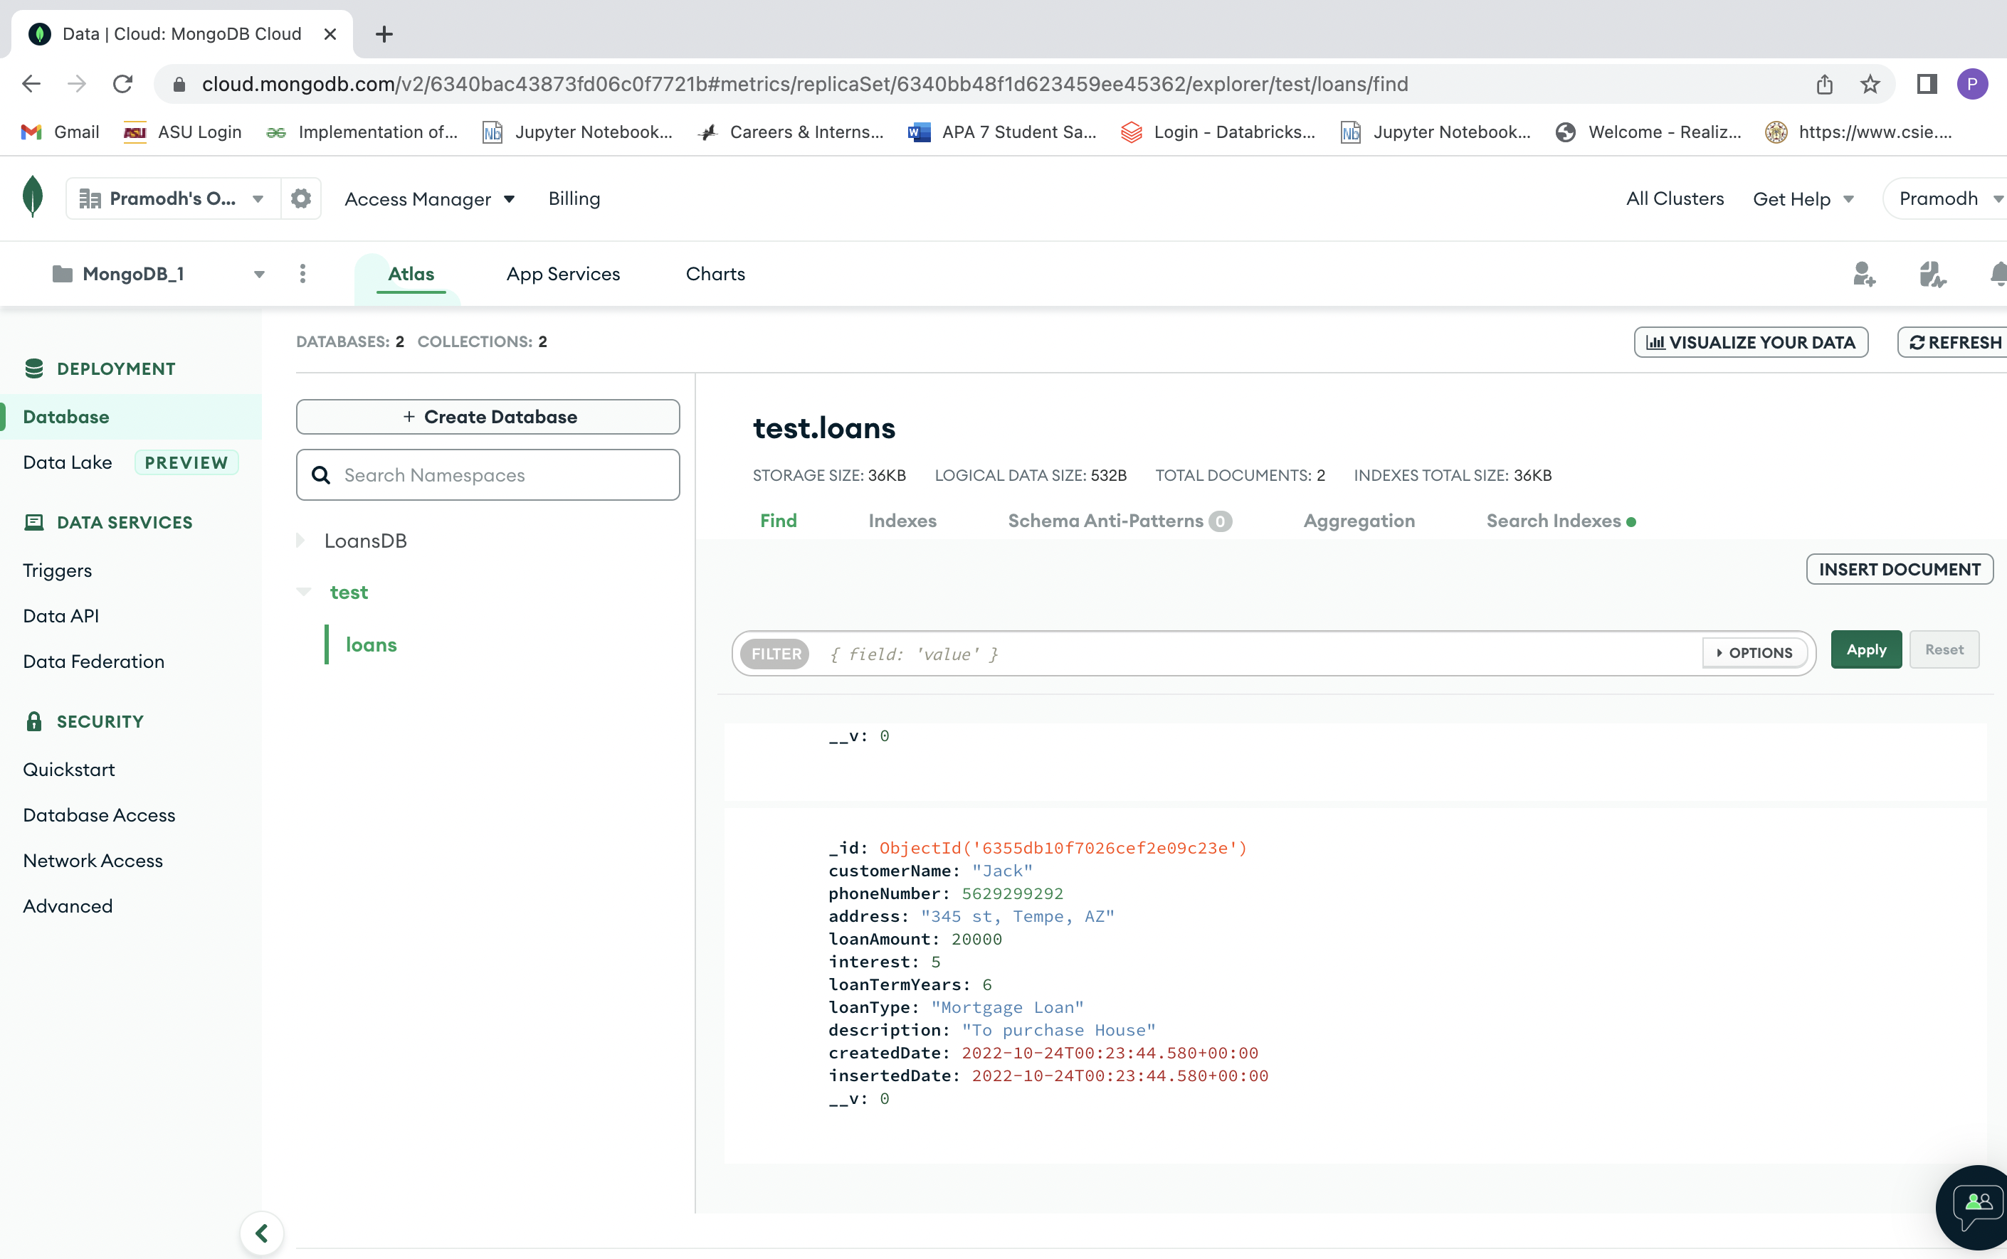

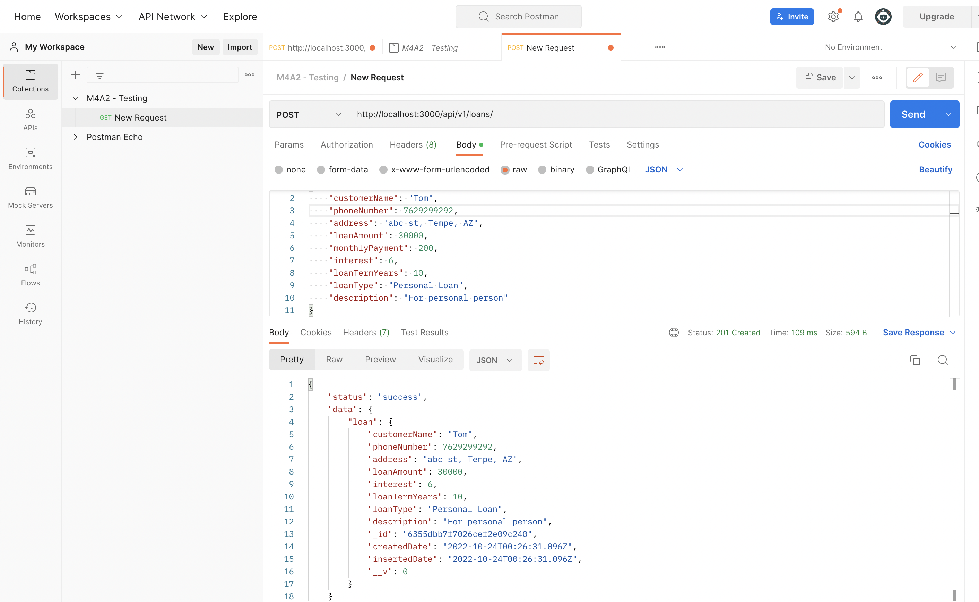

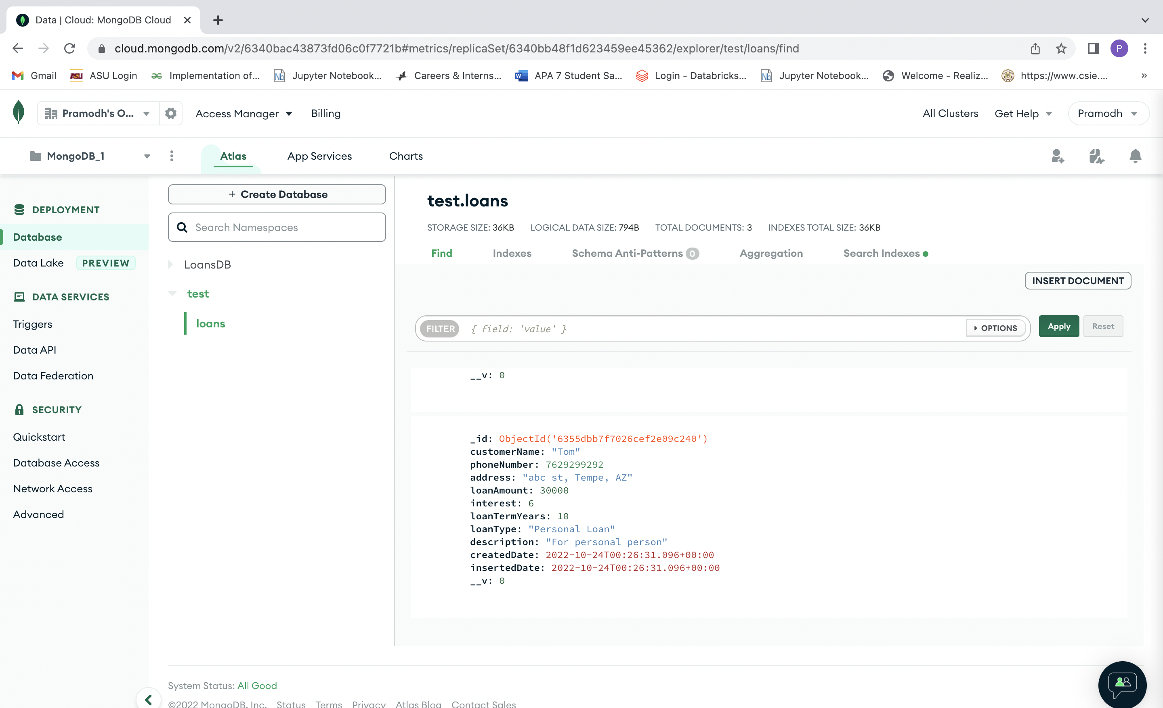

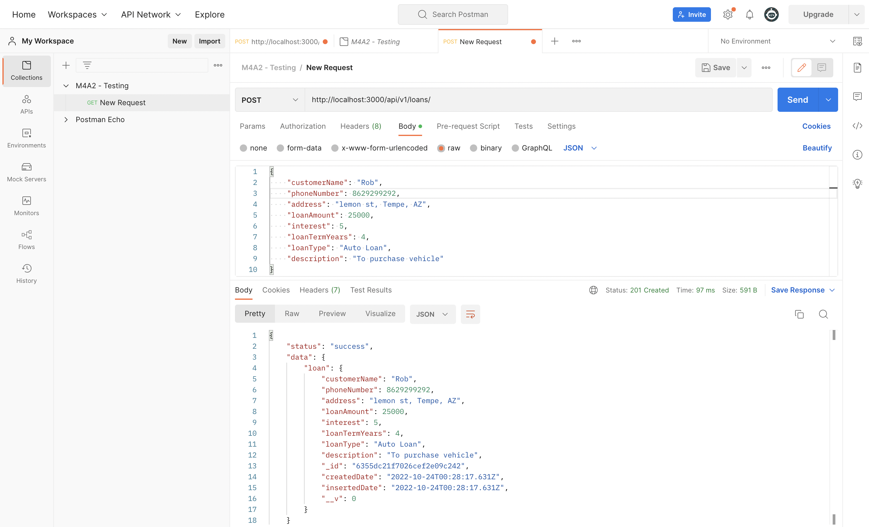

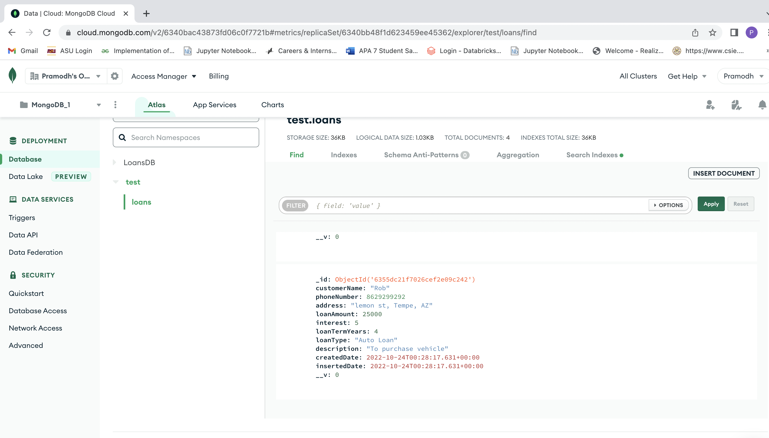

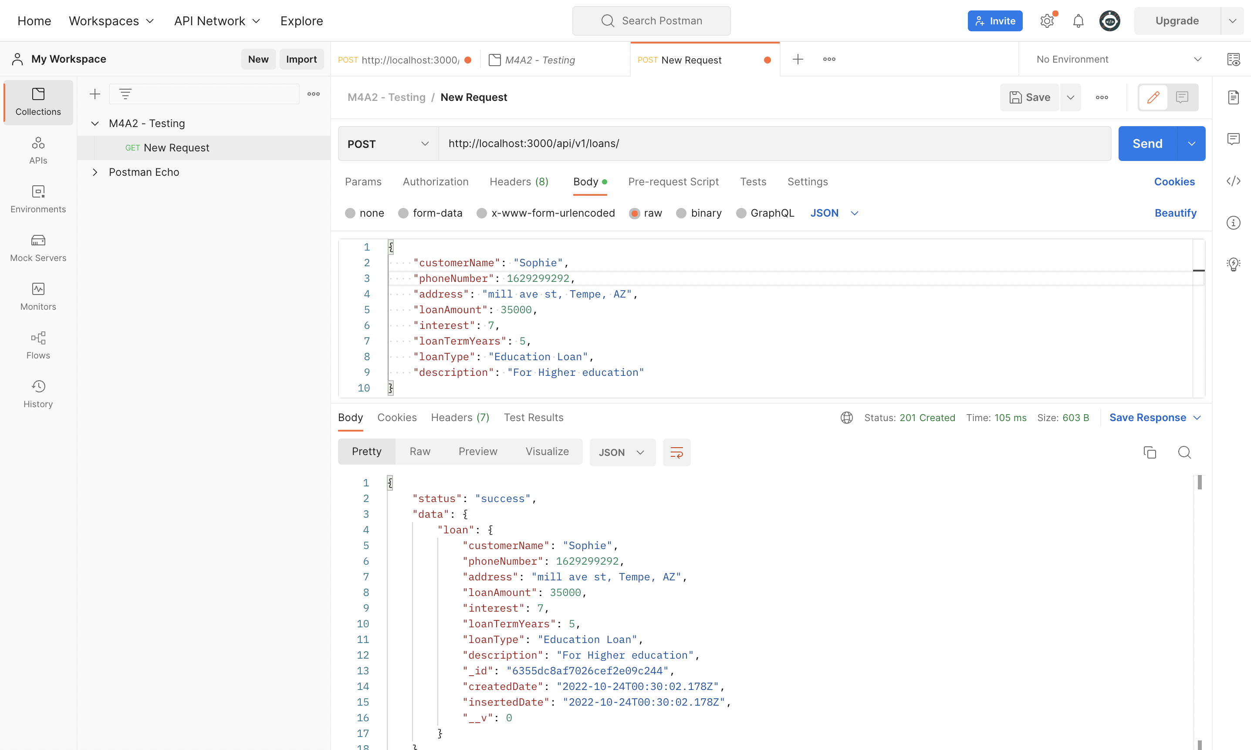

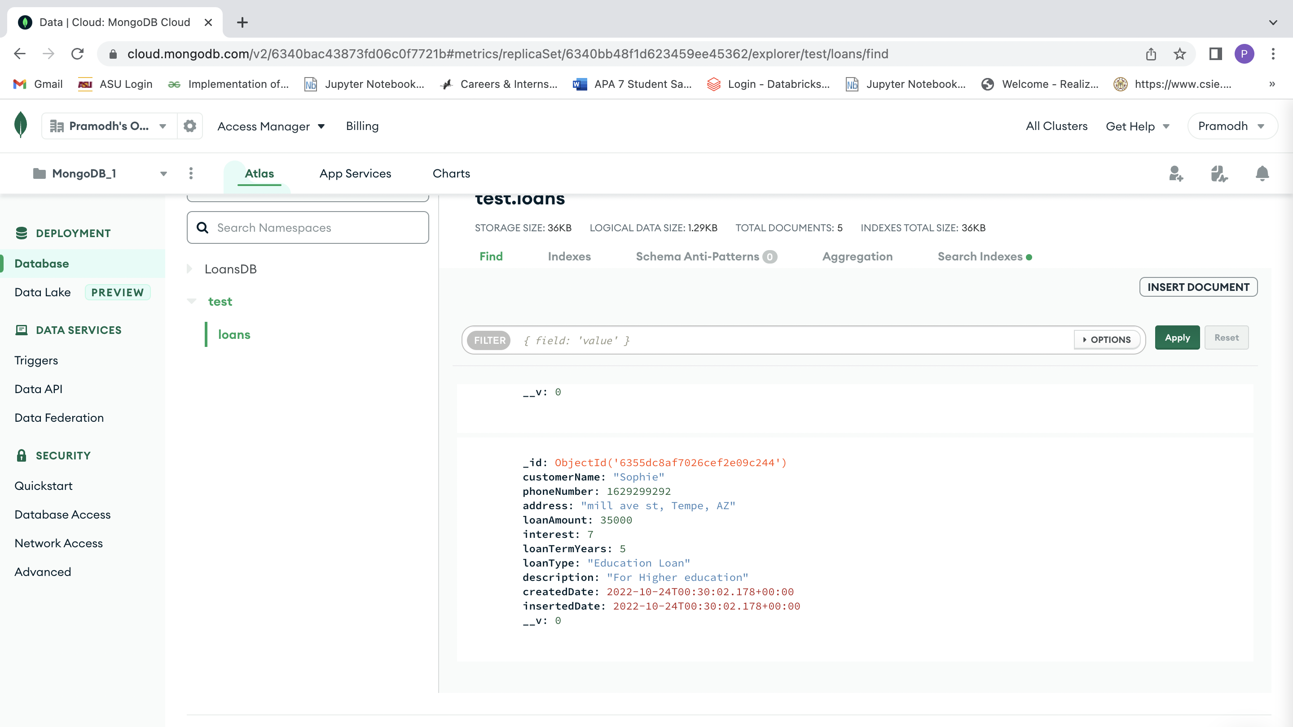

**2.Get all loans:**

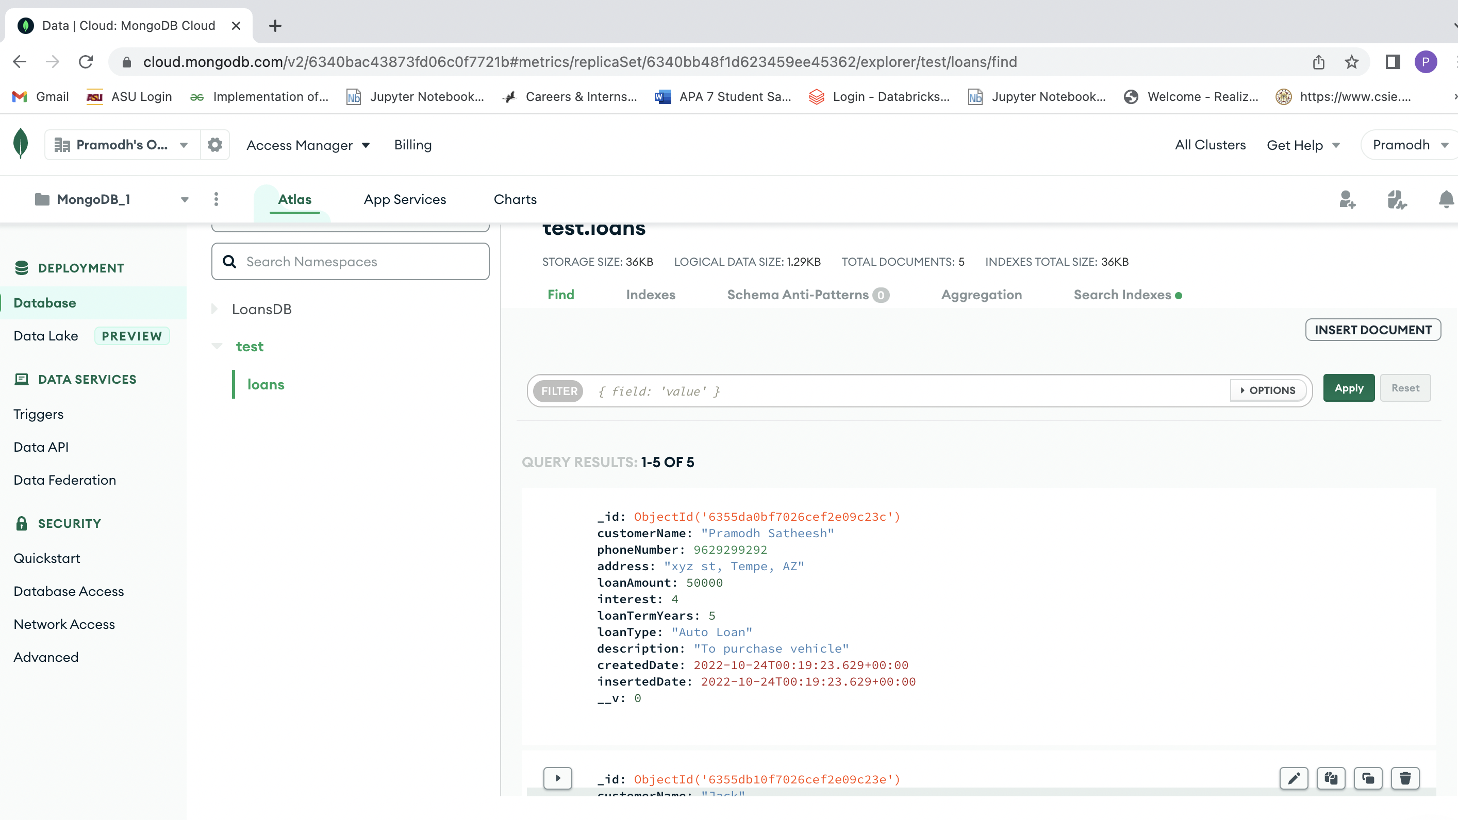

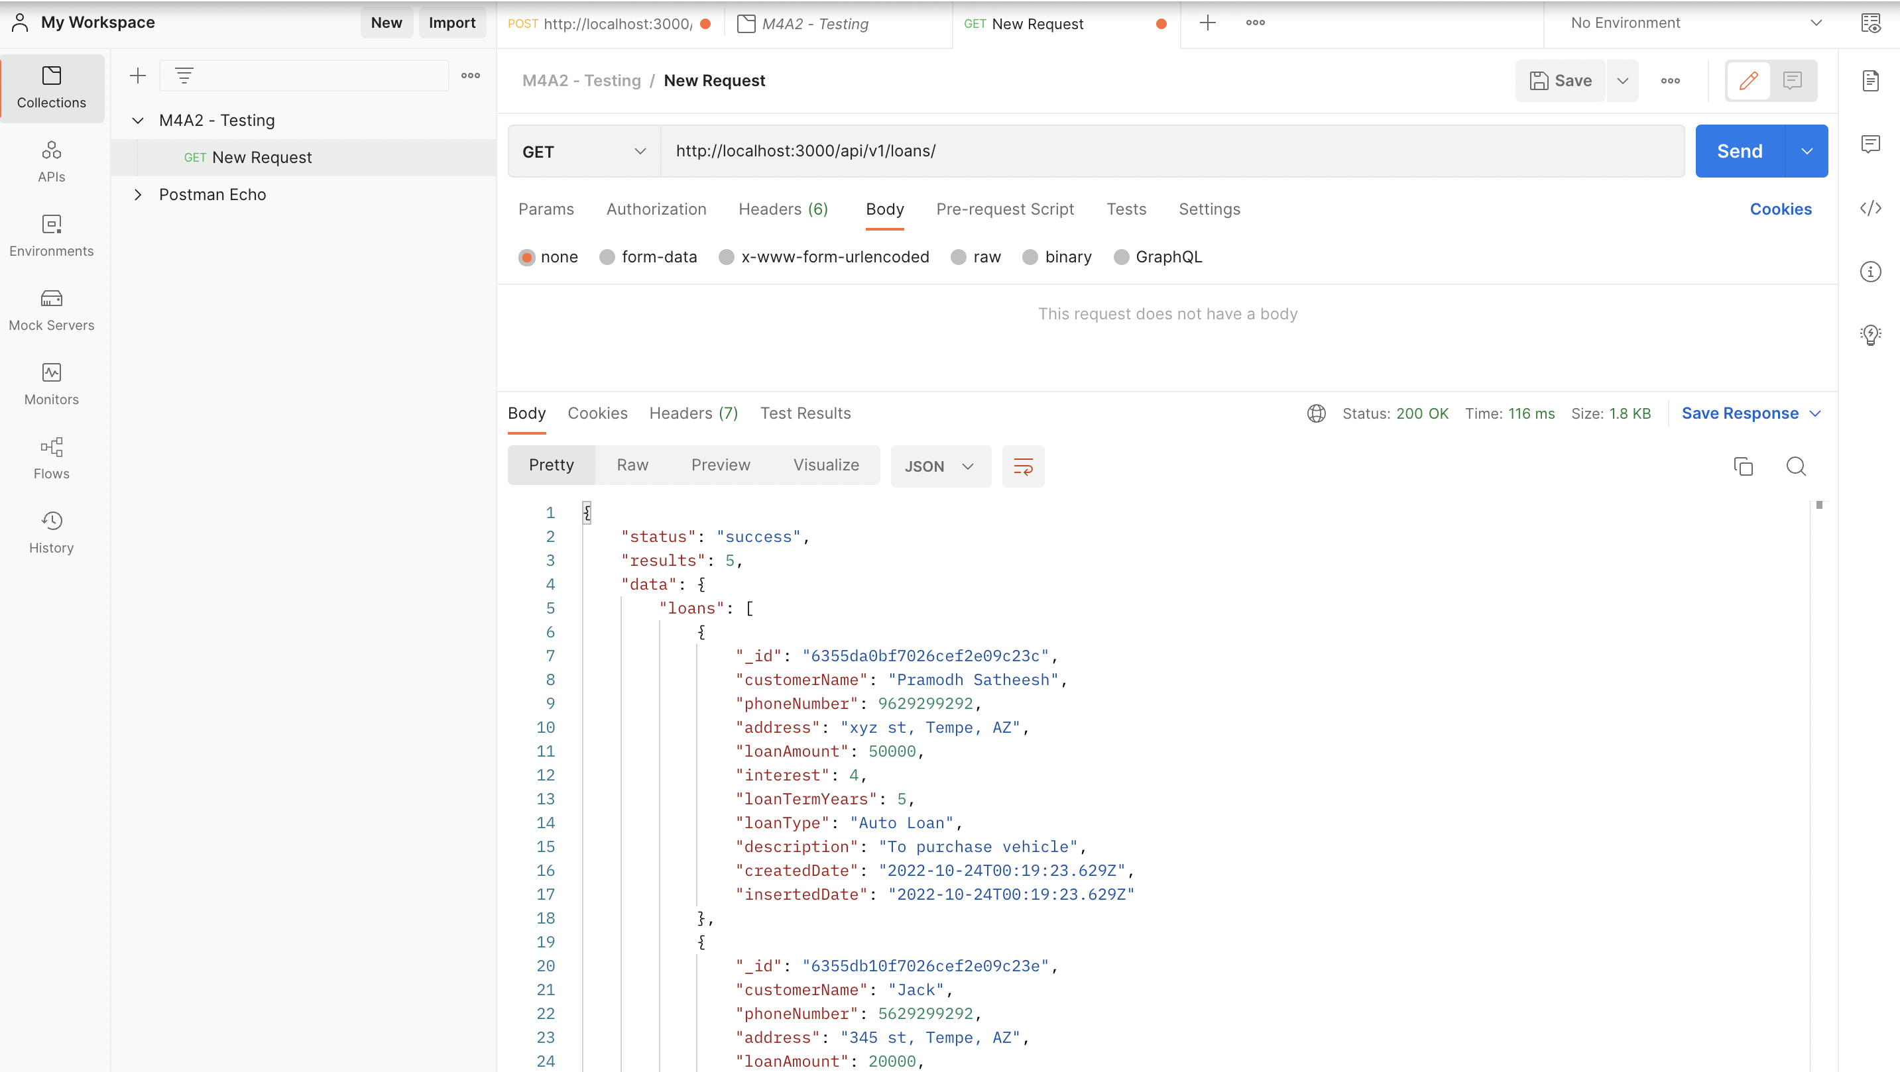

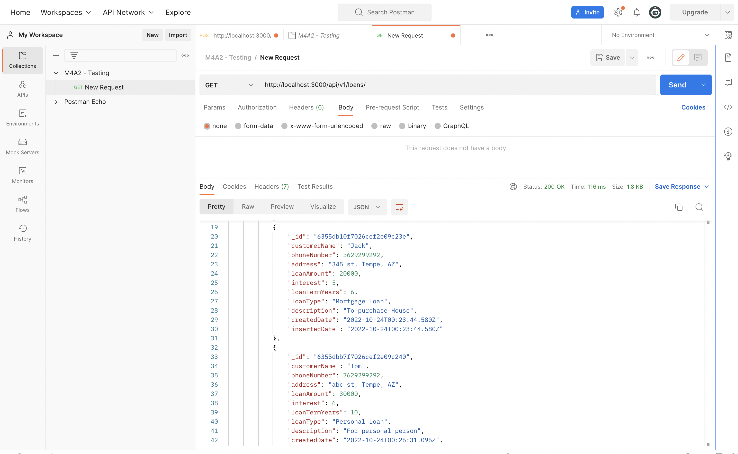

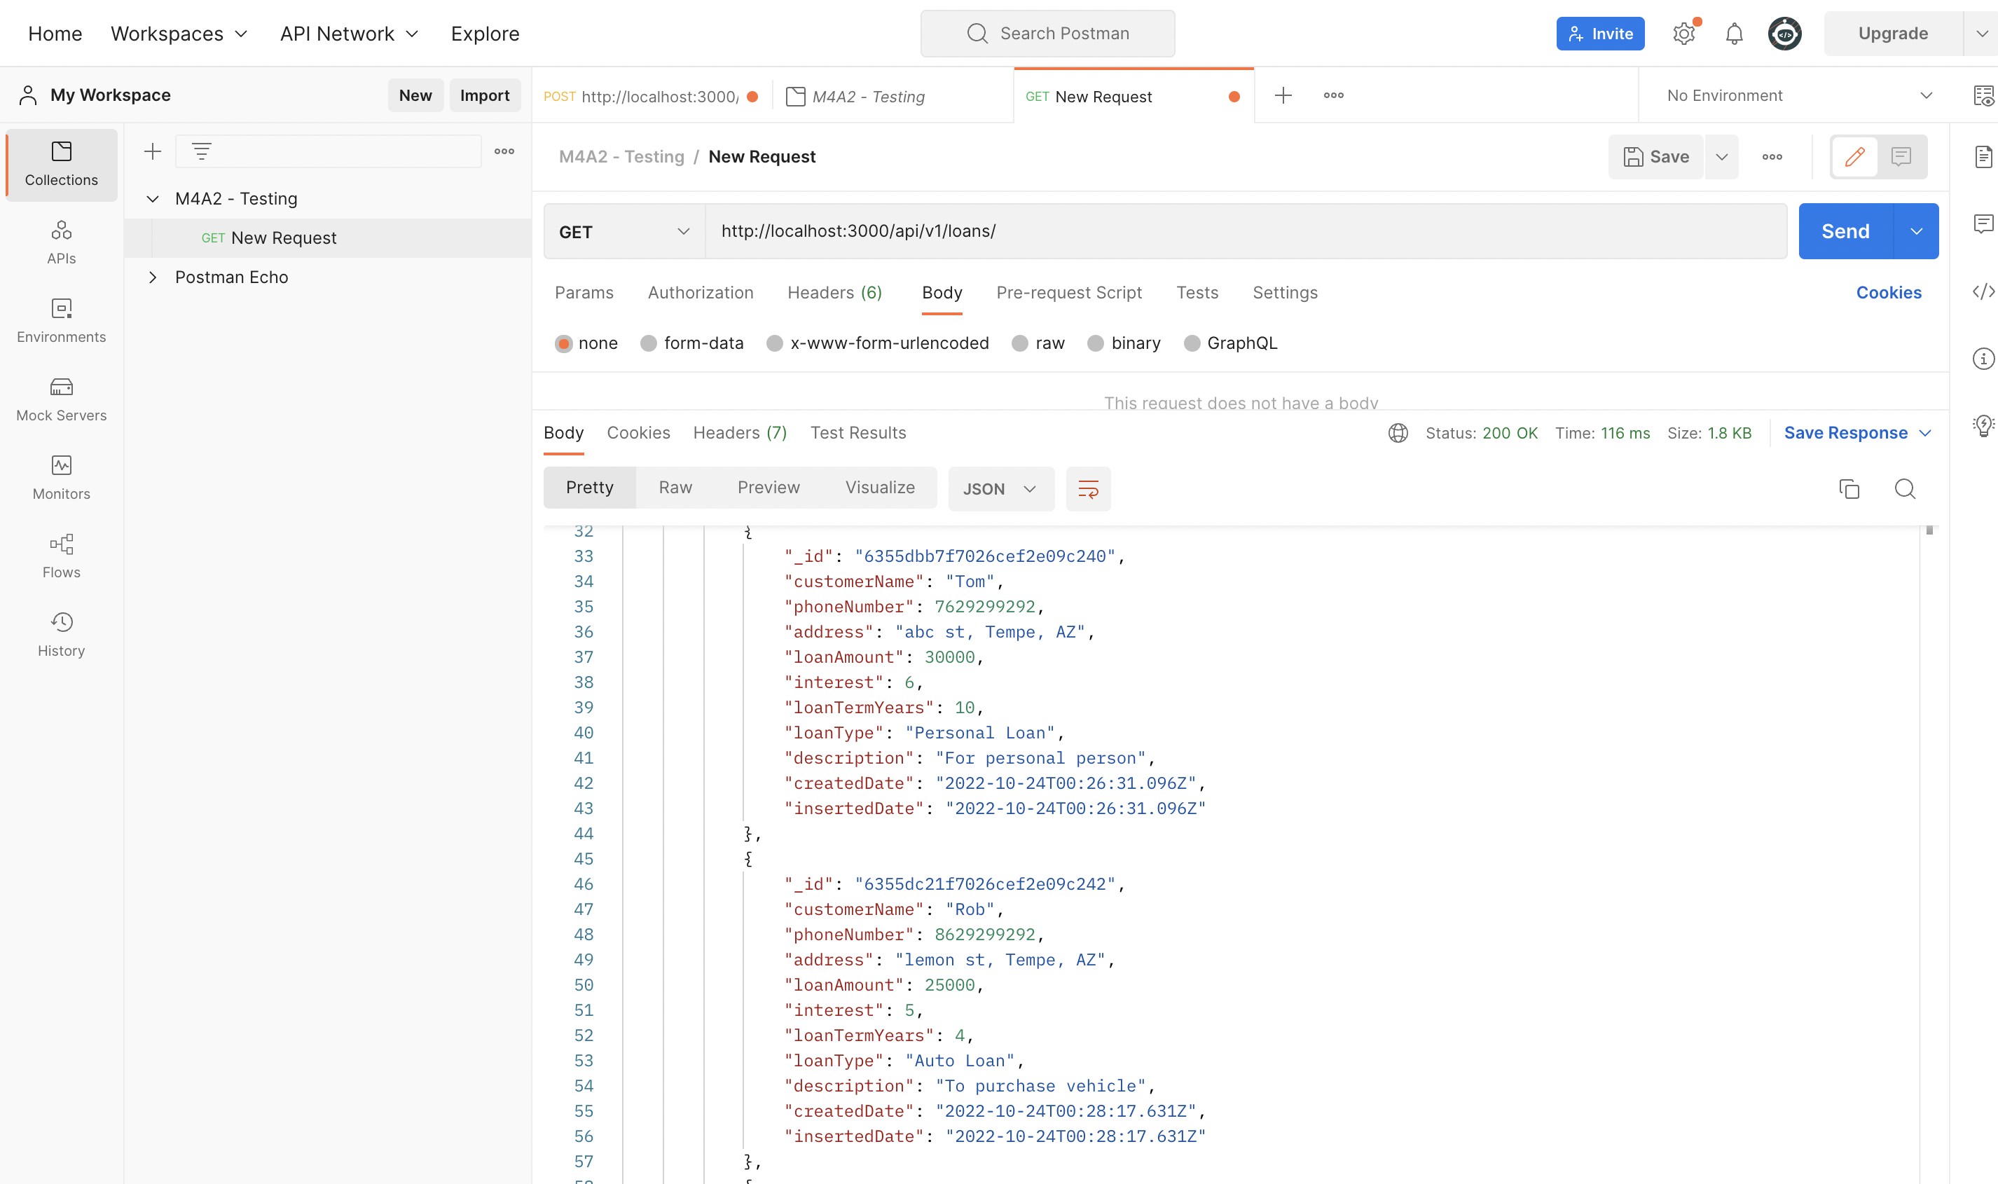

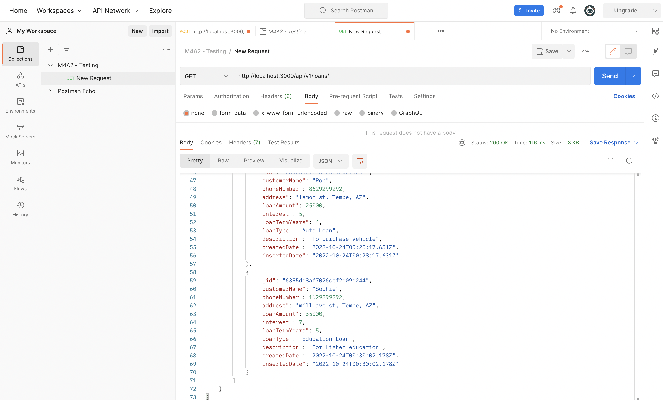

1. **Get a Specific Loan By ID**

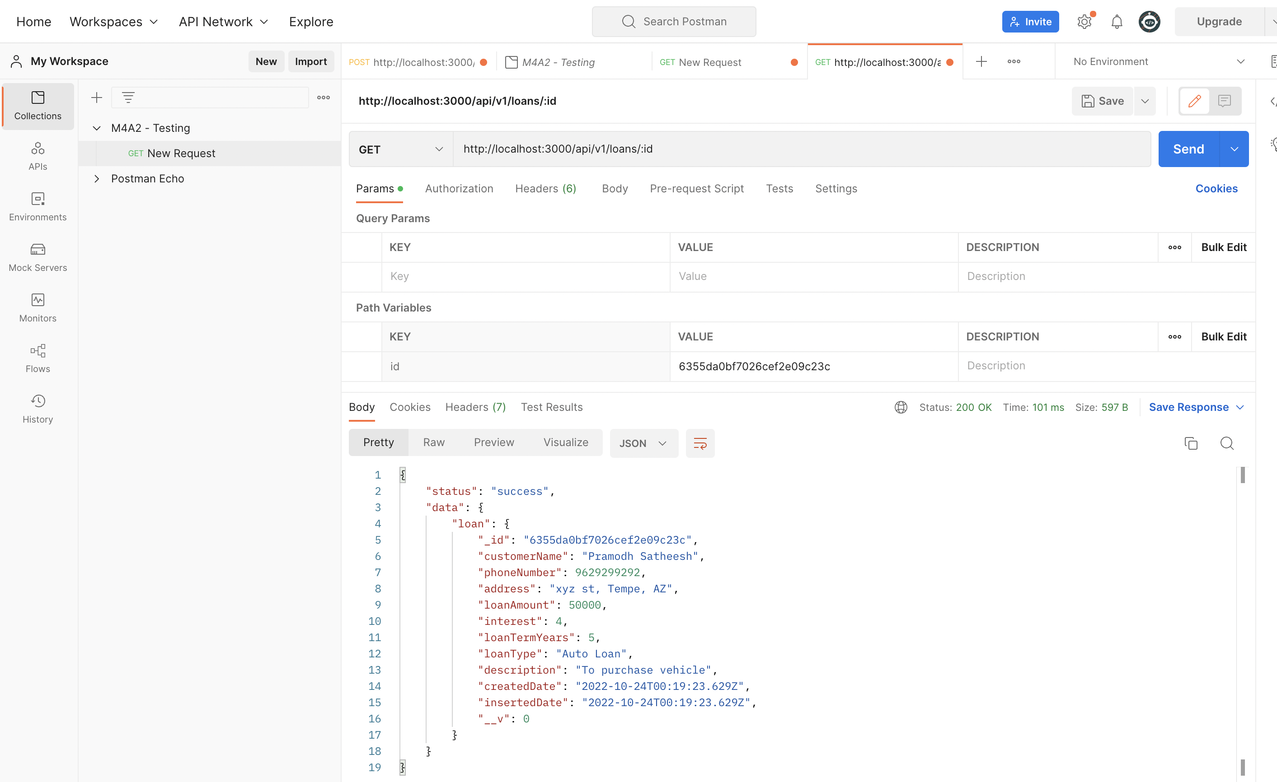

1. **Change an Existing Loan:**

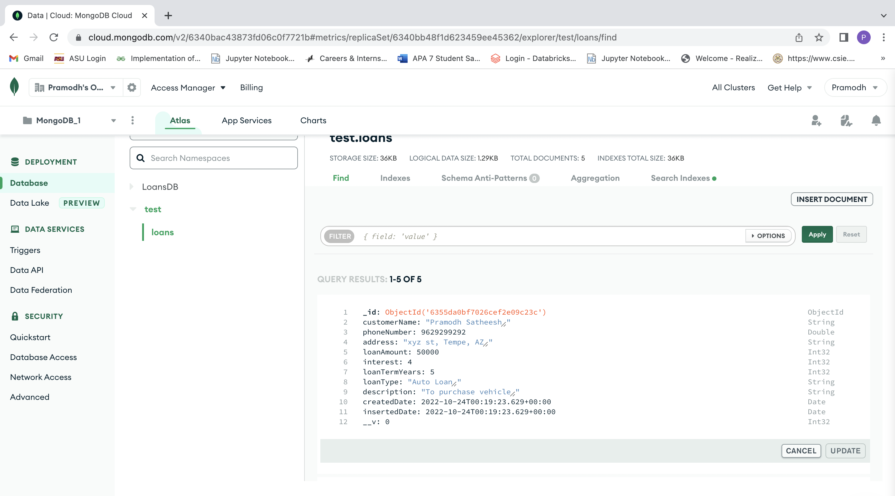

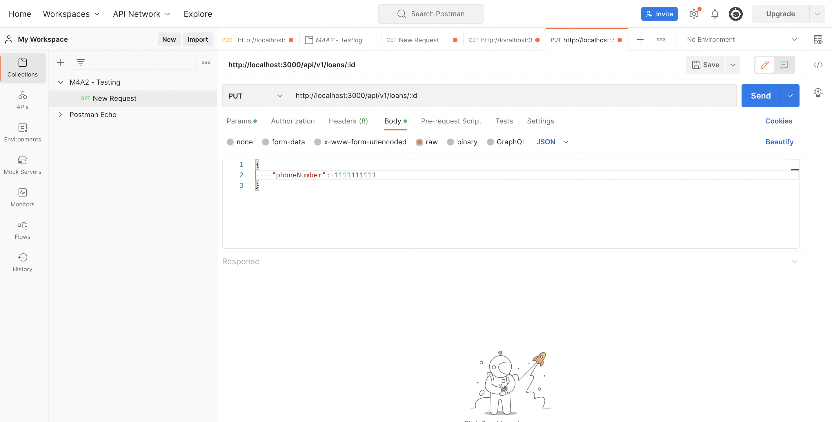

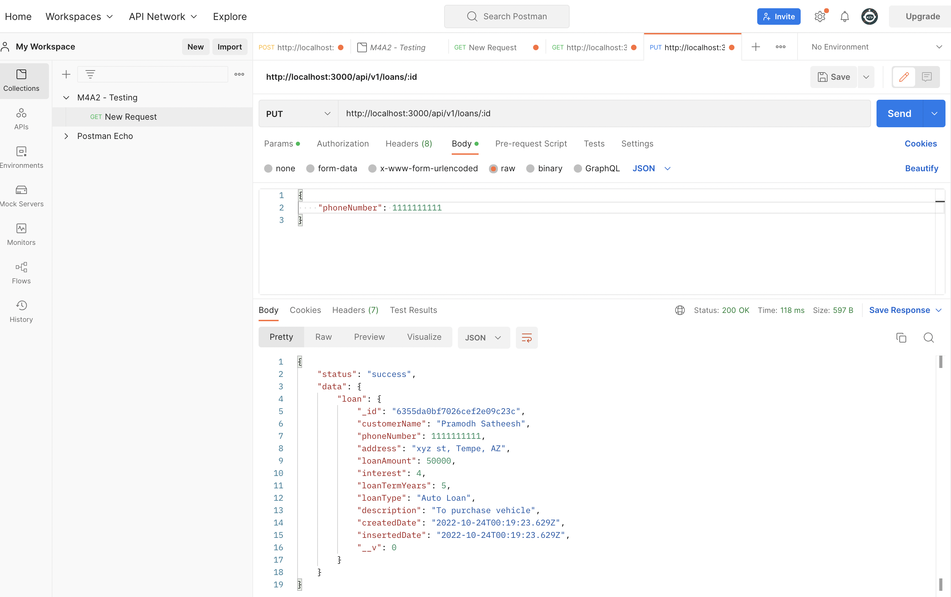

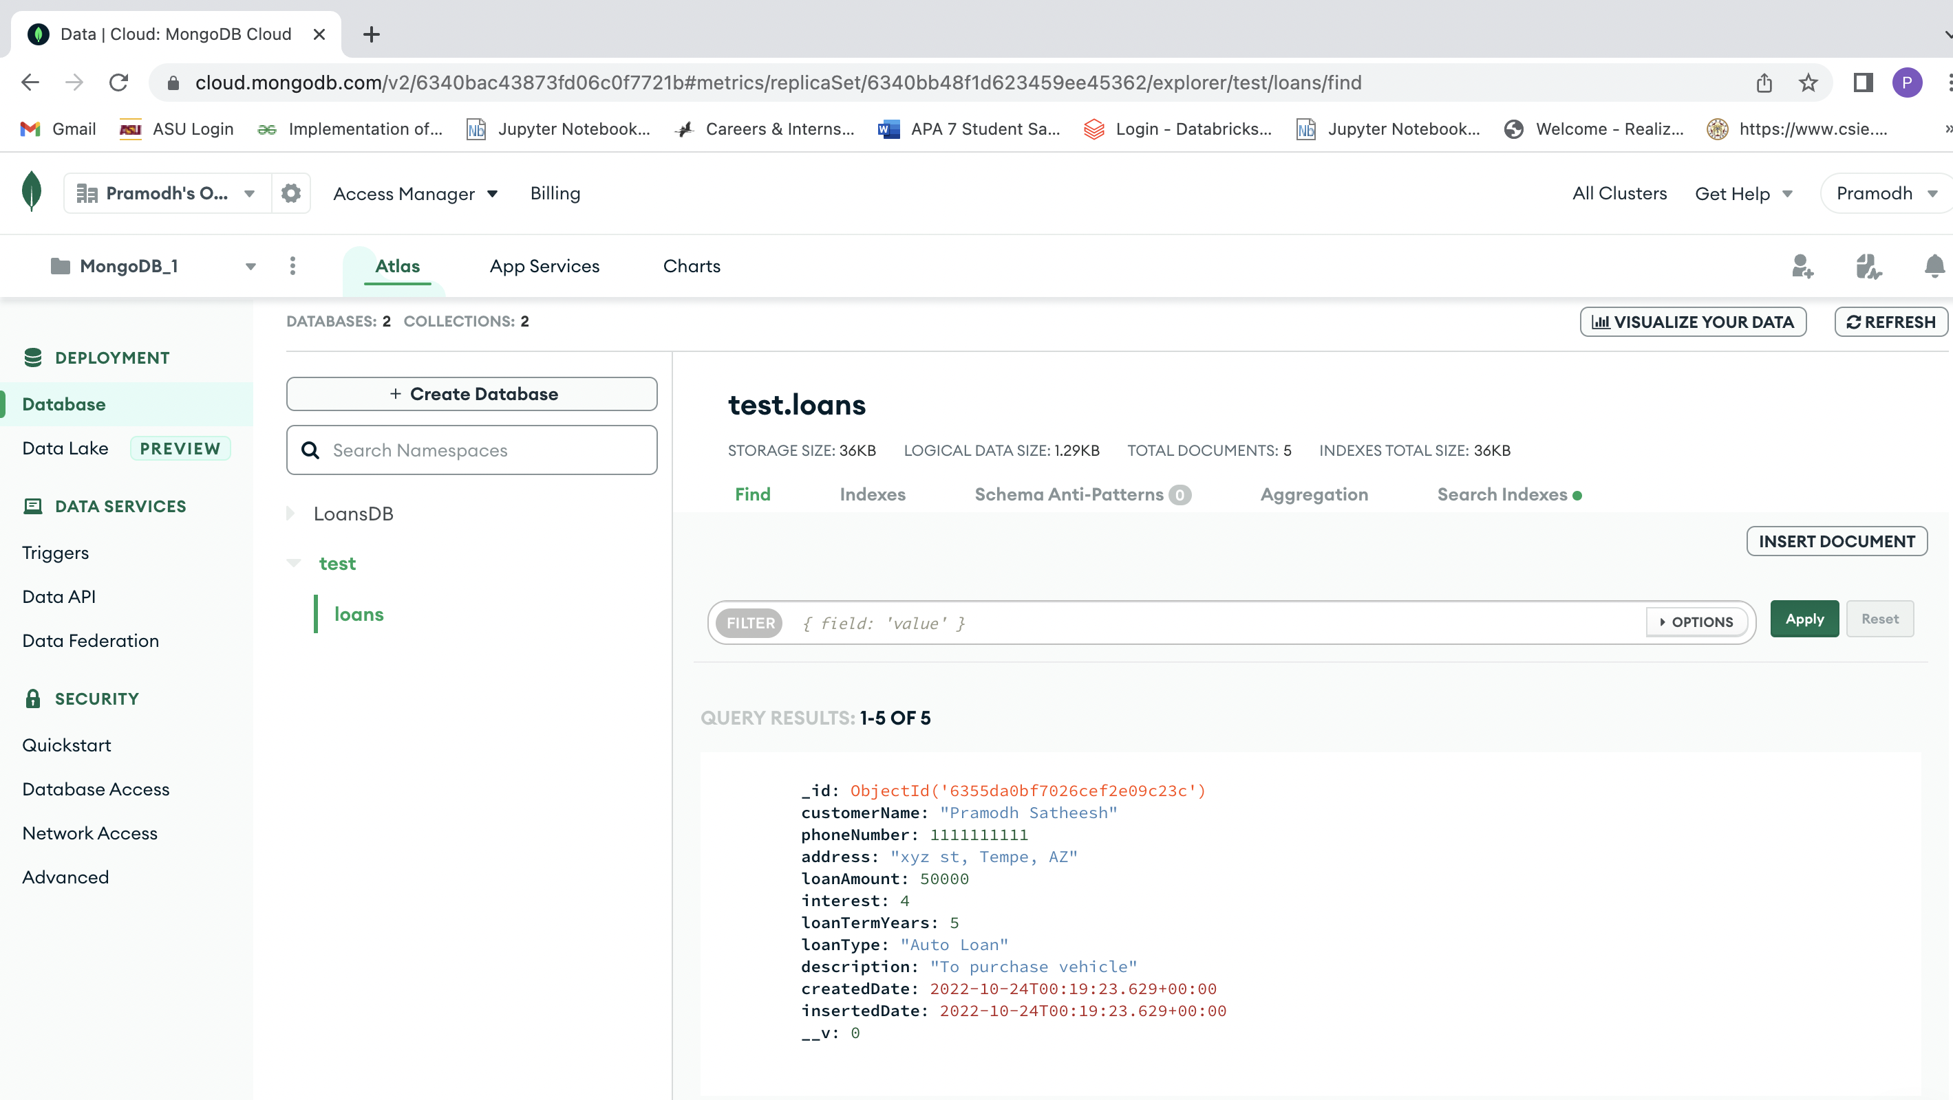

1. **Delete a loan:**

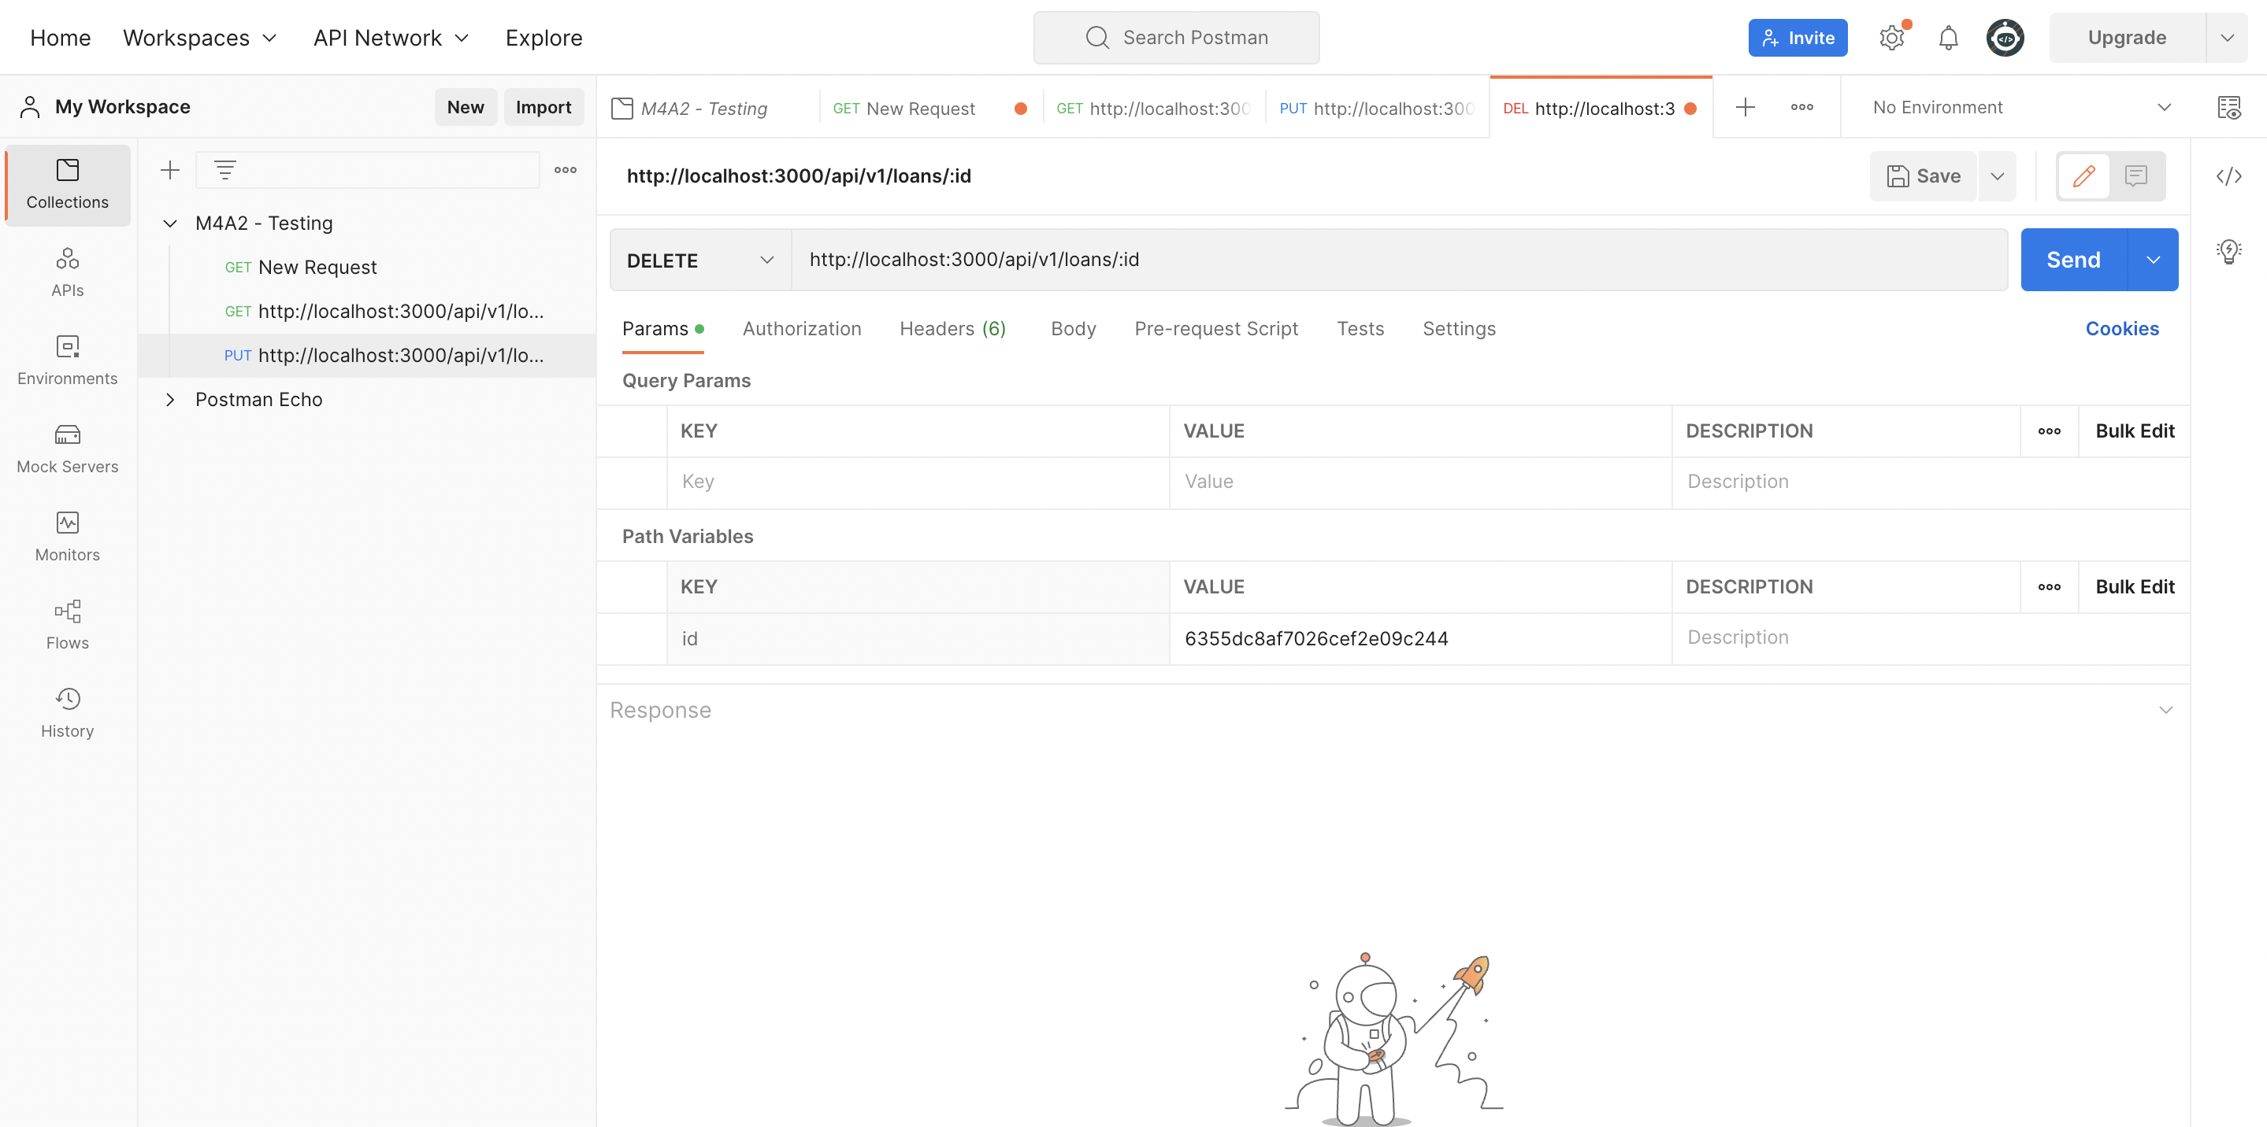

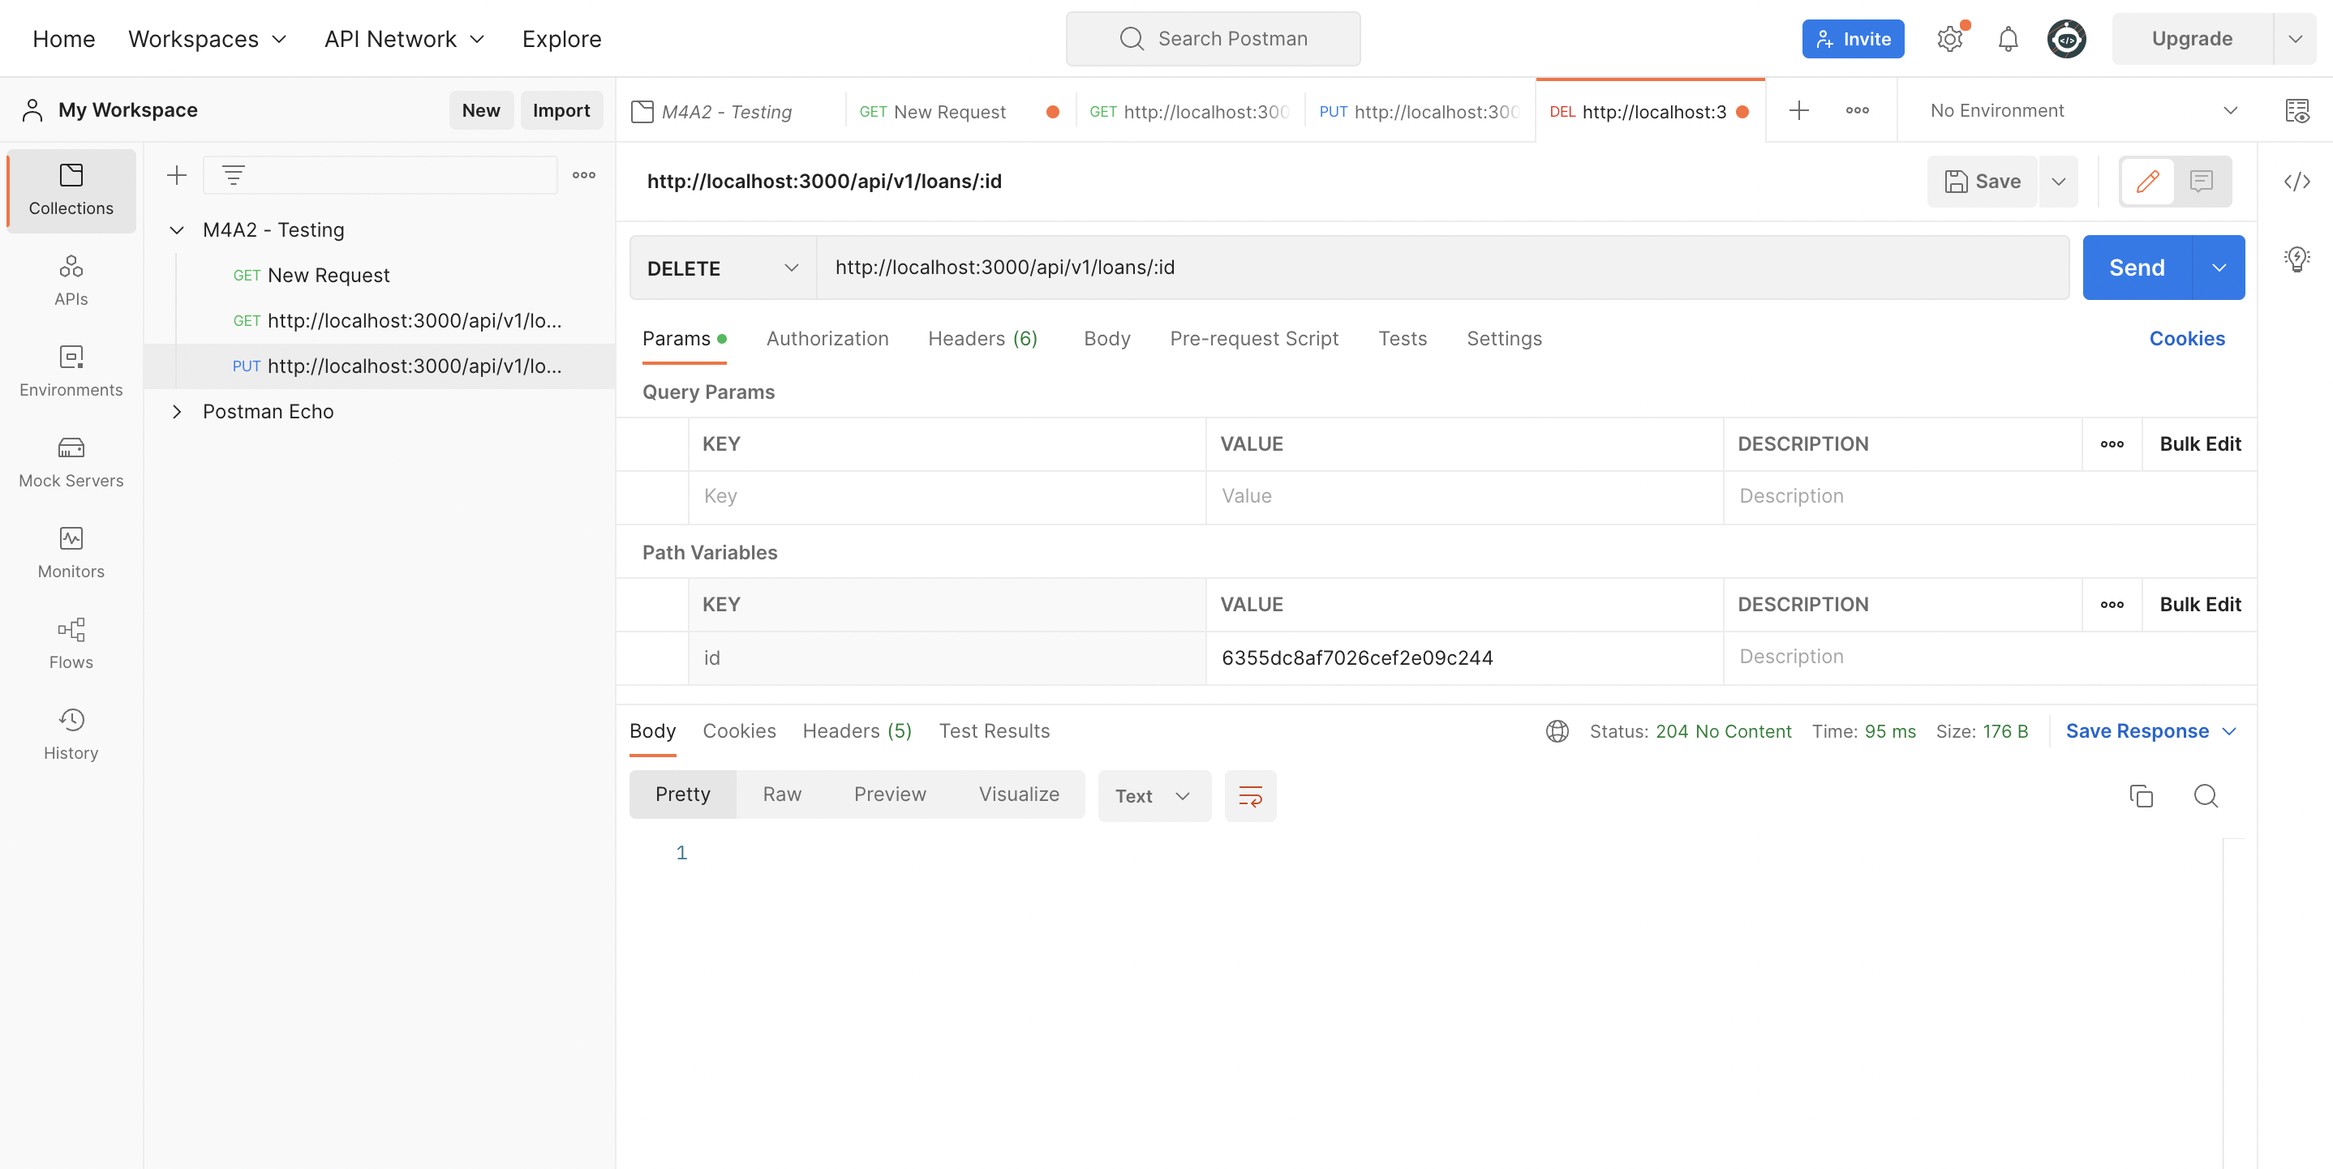

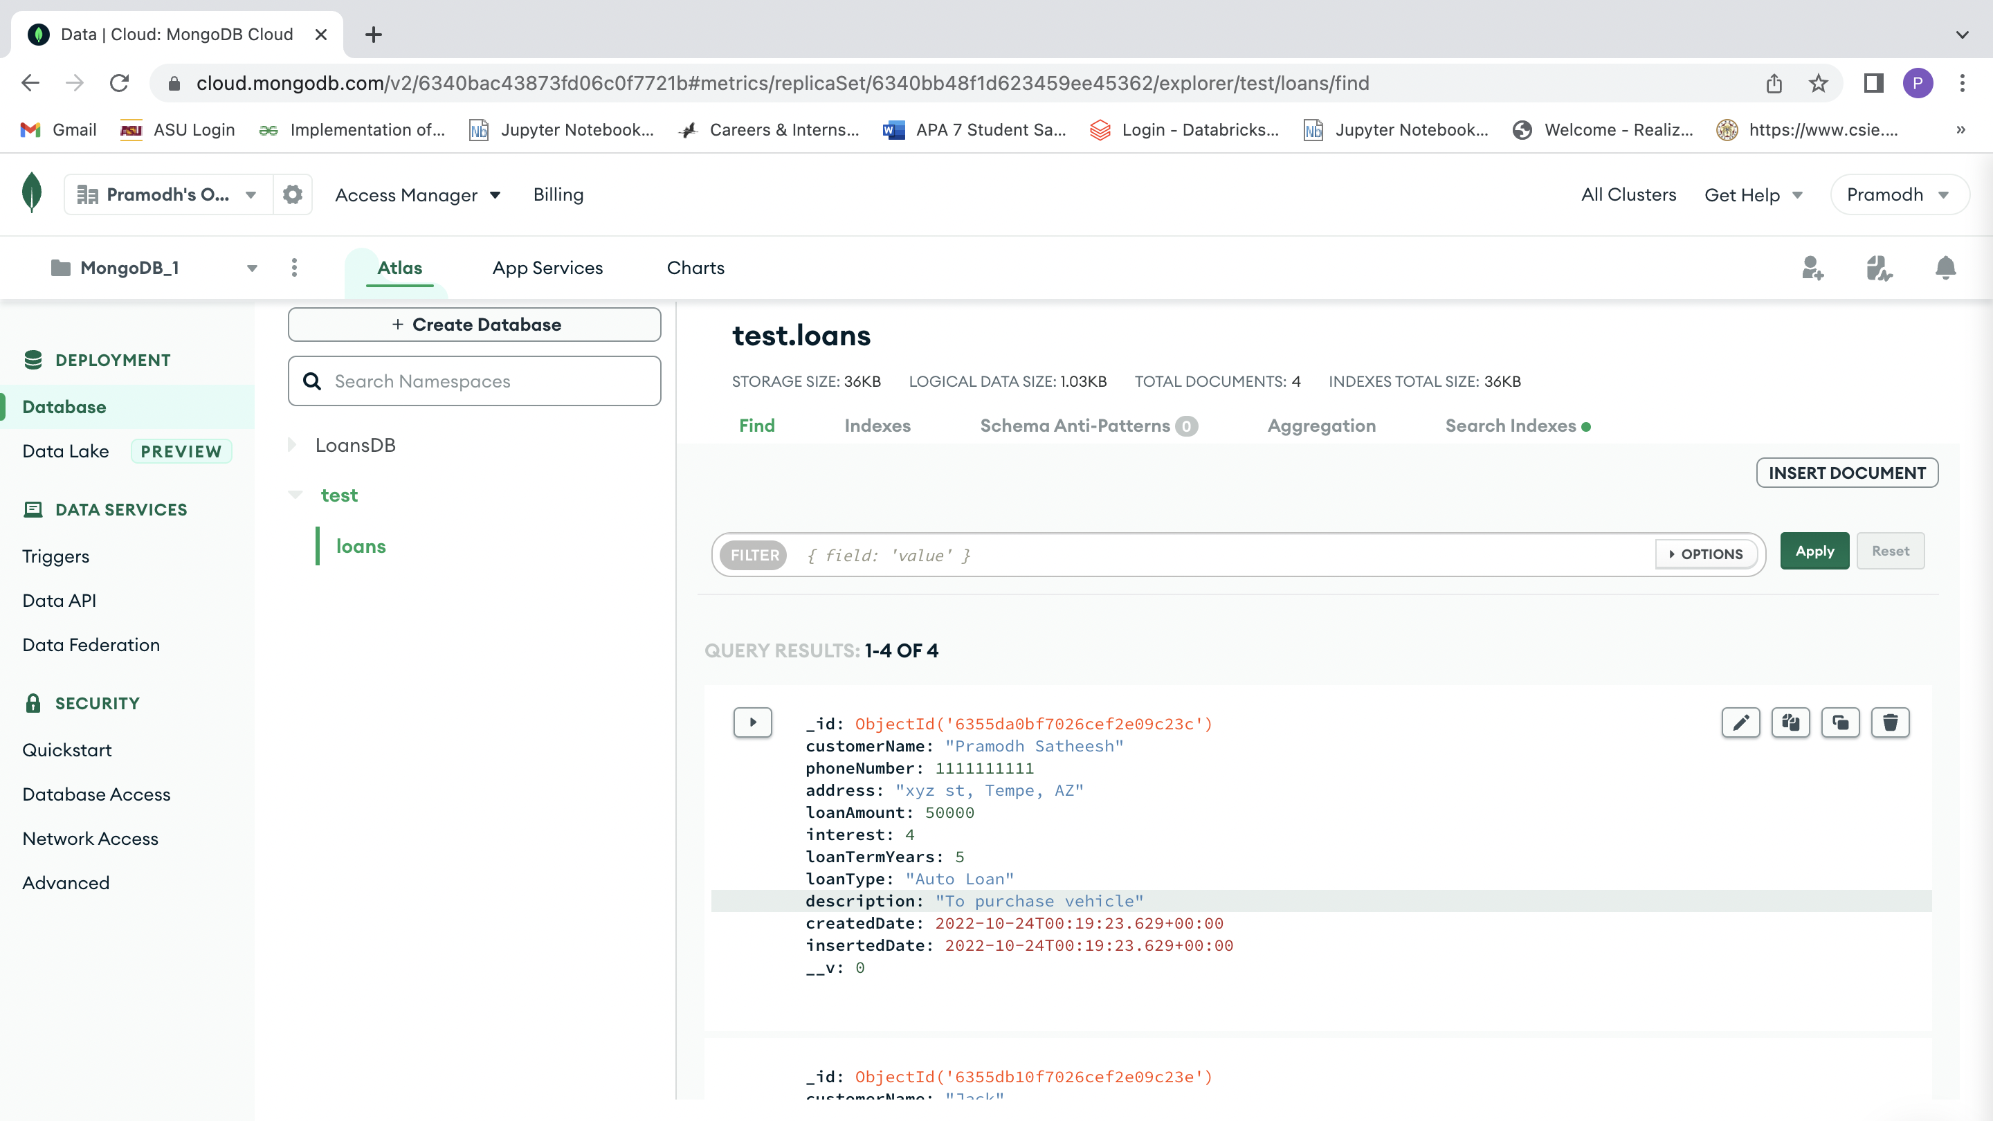

**Testing with error request or exceptions**

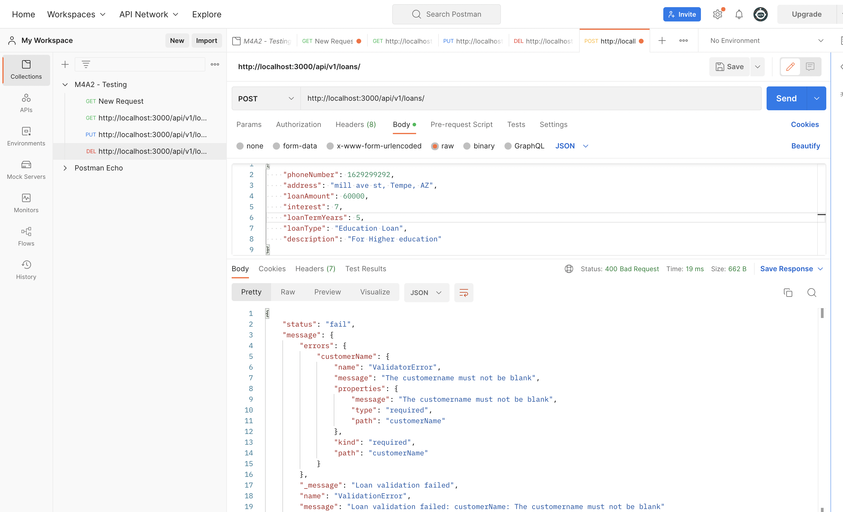

**Exporting the postman test collection to a JSON file:**

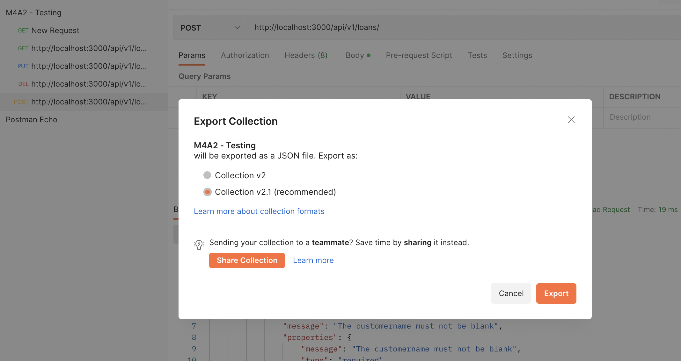

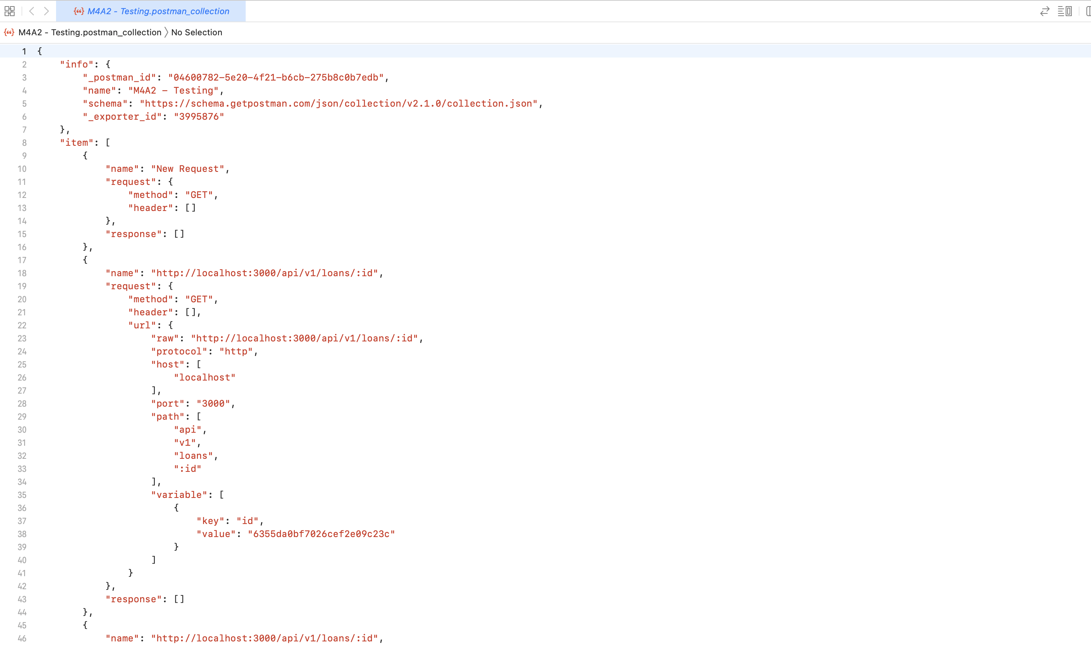

**GitHub Repository link:**